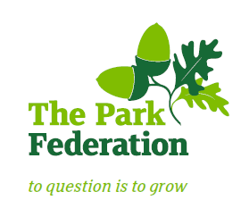
The Park Federation Academy Trust
Modern Slavery Statement

This statement is made pursuant to Section 54 of the Modern Slavery Act 2015 and sets out the steps that The Park Federation Academy Trust will take and continue to take to ensure that modern slavery or human trafficking is not taking place within our business or supply chain.
Modern slavery is a crime and a violation of fundamental human rights. It takes various forms, such as slavery, servitude, forced and compulsory labour and human trafficking, all of which have in common the deprivation of a person's liberty by another in order to exploit them for personal or commercial gain.
At The Park Federation Academy Trust we have a zero-tolerance approach to modern slavery and we are committed to acting ethically and with integrity in all our business dealings and relationships and to implementing and enforcing effective systems and controls to ensure modern slavery is not taking place anywhere in our business. This policy will apply to all persons working for us or on our behalf in any capacity, including employees at all levels, directors, agency workers, subcontractors, seconded workers, contractors, external consultants, third-party representatives and business partners.
Due Diligence process
The Board has discussed the Modern Slavery Statement compliance and to commence our developing Modern Slavery Statement are in agreement with the following proposals for 2019/20 and 2020/21 academic years:
- Make our staff aware of the Modern Slavery Act 2015 by including training alongside annual Safeguarding training during September staff training days. All staff are required to attend at their individual academies
- Contact suppliers and partners to check what assurance arrangements are in place.
- Commence a revision of our major procurement contracts to include compliance with the legislation.

Chief Executive Officer
Dr M Young

March 2019

