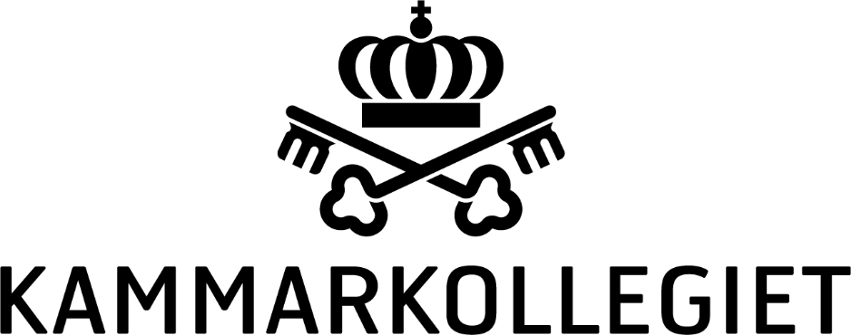

[Date Month Year]

FOLLOW-UP OF HUMAN RIGHTS ABUSES IN XINJIANG AND THE USE OF FORCED LABOUR OF UYGHUR AND OTHER TURKIC AND MUSLIM PEOPLES IN CHINA
This communication is a joint initiative between [the Church of Sweden, SKL Kommentus and the Swedish Regions] (hereby “signatories”).
Our efforts are part of a larger follow-up of a number of suppliers in several industries[, which also involves [the Church of Sweden, SKL Kommentus and the Swedish Regions].
The document clarifies the procuring organisations’ standpoint, reiterates the expectations on suppliers with regards to human rights due diligence and serves as a basis for follow-up of compliance with the organisations’ agreement conditions.

Background
There is credible evidence that the government of China is perpetrating human rights abuses on a massive scale in Xinjiang, known to local people as East Turkestan, targeting the Uyghur population and other Turkic and Muslim peoples on the basis of their religion and ethnicity. These abuses include arbitrary mass detention of an estimated range of 1 million to 1.8 million people and a program to “cleanse” ethnic minorities of their “extremist” thoughts through re-education and forced labour.
The government’s poverty alleviation programs in Xinjiang include detainee labour inside these internment camps and multiple forms of involuntary labour at workplaces across the region. The programs are coupled with mutual pairing assistance programs, in which companies from east China are incentivized to establish satellite factories near the camps. Local governments also receive funds for each individual from the camps forced to work in these sites at a fraction of minimum wage or without compensation. These repressive policies are then bolstered by a pervasive, technology-enabled system of surveillance.
The government is furthermore transporting Uyghurs and other Turkic and Muslim peoples to other parts of China, where they are working in factories under conditions strongly indicating forced labour. Reports in 2020 revealed that at least 80,000 Uyghurs or other Turkic and Muslim peoples have been transferred to factories across China where they cannot leave, are under constant surveillance, and must undergo “ideological training” to abandon their religion and culture.

Signatories’ Supply Chains
There is a grave risk that suppliers in the signatories’ supply chains are benefiting from human rights violations, including forced labour, both in and from Xinjiang. This is especially true in the textile and garment sectors. More than 80 percent of China’s cotton is grown in Xinjiang, approaching 20 percent of global production. Fabric made with cotton from Xinjiang is used by factories across China and the world.
Other sectors identified as high risk are electronics manufacturing, including cell phones and printing products, rare earth mining and other extractives, agricultural production, plastics, cleaning supplies and chemicals, medical equipment, electrical machinery, mechanical appliances, toys and sports equipment, and vehicles.

Signatories’ Agreement Conditions
All signatories require suppliers to perform contracts in accordance with the UN Declaration of Human Rights and the ILO core conventions, including:
- Forced Labour Convention (No. 29)

- Abolition of Forced Labour Convention (No. 105)

- Discrimination (Employment and Occupation) Convention (No. 111)
All signatories also require suppliers to ensure that sub-suppliers satisfy these requirements. The suppliers must furthermore take reasonable measures to comply with international regulations, if they provide stronger protection than national legislation.
Lastly, all signatories require suppliers to have policies and processes for human rights due diligence in place. Many of the signatories’ agreements explicitly refer to the UN Guiding Principles on Business and Human Rights, or equivalent guidelines such as the OECD Due Diligence Guidance for Responsible Business Conduct.

Human Rights Due Diligence
In accordance with the signatories’ agreement conditions, suppliers must actively monitor the above human rights risks including the risk of forced labour.
While human rights due diligence best practices typically include having the ability to conduct independent onsite inspections and working with sub-suppliers to remediate forced and abusive labour practices, the repressive conditions in Xinjiang make it unlikely that suppliers will have the necessary access to sub-suppliers. Third-party audits may not be a credible source of information for the following reasons:
- Auditors have reportedly been detained, harassed, threatened or stopped at the airport.

- Auditors may be required to use a government translator who conveys misinformation or does not speak in workers’ first language.

- Auditor interviews with workers cannot be relied upon given the pervasive surveillance and evidence of workers’ fear of sharing accurate information.
If suppliers are not able to identify, prevent and mitigate human rights violations including forced labour, suppliers may need to end relationships with sub-suppliers in order to meet the corporate responsibility to respect human rights. Both the UN Guiding Principles on Business and Human Rights (Principle 19) and the OECD Due Diligence Guidance (3.2) note that businesses should end or disengage from business relationships where prevention or mitigation of harm is not possible by other means, while assessing potential adverse human rights impacts of doing so.

Required Actions
- In order to ensure compliance with the agreement conditions, suppliers must investigate whether forced labour of Uyghur and other Turkic and Muslim groups occurs in the supply chains of the signatories' subject matters of procurement. The investigation should at least include:

- Manufacturers with production facilities located in Xinjiang.

- Manufacturers that have employed, at a workplace outside Xinjiang, workers from Xinjiang who were sent by the government.

- Manufacturers that source inputs produced in Xinjiang, such as but not limited to fabric, yarn or cotton.

- Upon identification of any of the business relationships enumerated above, suppliers should operate on the assumption that its supply chain is linked to the forced labour of Uyghur and other Turkic and Muslim groups, and take the following actions in accordance with international best practice:

- Disengage from manufacturers with production facilities located in Xinjiang, unless there is credible evidence that the manufacturer is not complicit in human rights violations including forced labour.

- Disengage from manufacturers whereby there is credible evidence that the manufacturer has employed, at a workplace outside Xinjiang, workers from Xinjiang who were sent by the government.

- Instruct all manufacturers to end all sourcing of inputs produced in Xinjiang for the signatories’ products, such as but not limited to fabric, yarn or cotton, unless there is credible evidence that the input-supplier is not complicit in human rights violations including forced labour. If a manufacturer does not agree to take these steps, or does not provide proof that it has done so, disengage from the manufacturer.

- Suppliers to the signatories may refrain from ending the relationships in a), b) and c) if the manufacturer or input-supplier stops the use of forced labour and remediation is provided. Suppliers shall also direct all manufacturers not to use government-provided labour from Xinjiang for the production of the signatories’ products and shall conduct verification of facilities used for the manufacture of the products via credible methods developed to detect this specific type of state-imposed forced labour. See Annex 1 for relevant indicators.

- Suppliers to the signatories may also refrain from ending the relationships in a), b) and c) if the manufacturer or input-supplier is a crucial business relationship. A relationship could be deemed crucial if it provides a product or service that is essential to the supplier’s business, and for which no reasonable alternative source exists.

- Where exit of relationships is deemed necessary, suppliers shall assess potential adverse human rights impacts of exiting.

- Suppliers shall report [monthly/quarterly/six-monthly/yearly] to the signatories’ contact point in accordance with the attached “Template for follow-up in China”. The reporting shall include all manufacturers listed under 1 a), b) and c), including any relevant manufacturers in Annex 2.

These obligations remain in force until the signatories are satisfied that suppliers have reached a reasonable level of credibility in terms of the absence of forced labour of Uyghur and other Turkic and Muslim groups in supply chains.
Signatories’ suppliers are also encouraged to collaborate with industry and multi-stakeholder groups to exercise leverage to address and prevent human rights abuses in their supply chains, including the sharing of information, the development of capacity to research indicators of forced labor in Chinese languages, and the building of relationships with manufacturers and input-suppliers to understand their possible involvement in poverty-alleviation programs and mutual pairing assistance programs.
Any information suppliers report within this context will be shared among the signatories.

[Church of Sweden
SKL Kommentus
The Swedish Regions]

”Concluding observations on the combined fourteenth to seventeenth periodic reports of China (including Hong Kong, China and Macao, China)”, United Nations Committee on the Elimination of Racial Discrimination, 19 September 2019.
Luke Adams, Steve Andrews, Scott Flipse, Megan Fluker, and Amy Reger, ”Staff Research Report: Global Supply Chains, Forced Labor, and the Xinjiang Uyghur Autonomous Region”, Congressional-Executive Commission on China, March 2020; Adrian Zenz, “‘Wash Brains, Cleanse Hearts’: Evidence from Chinese Government Documents about the Nature and Extent of Xinjiang’s Extrajudicial Internment Campaign”, Journal of Political Risk, 7 (11), November 2019; Fergus Ryan, Danielle Cave, and Nathan Ruser, “Mapping Xinjiang’s ‘Re-Education’ Camps”, Australian Strategic Policy Institute, 1 November 2018; “World Report 2019: Events of 2018: China”, Human Rights Watch, 2019.
The Chinese government’s terminology, see, for example, “‘Eradicating Ideological Viruses’: China’s Campaign of Repression Against Xinjiang’s Muslims”, Human Rights Watch, 9 September 2018.
“Xinjiang Supply Chain Business Advisory”, U.S. Department of Commerce, 1 July 2020.
Chris Buckley and Paul Mozur, “How China Uses High-Tech Surveillance to Subdue Minorities”, The New York Times, 22 May 2019.
Vicky Xiuzhong Xu, Danielle Cave, James Leibold, Kelsey Munro, and Nathan Ruser, “Uyghurs for Sale: ‘Re-education’, Forced Labour and Surveillance beyond Xinjiang”, Australian Strategic Policy Institute, 1 March 2020.
“The Australian Broadcasting Corporation’s Exposé on Forced Labor in Xinjiang”, Jernigan Global, 1028, 22 July 2019.
“Pairing Programs in Xinjiang: Priority Sectors and Human Rights Risks”, Center for Strategic & International Studies, 13 October 2020; “Xinjiang Supply Chain Business Advisory”, U.S. Department of Commerce, 1 July 2020.
“Xinjiang Supply Chain Business Advisory”, U.S. Department of Commerce, 1 July 2020.

