C H R Y S T A L
(K H R U S T A L’)

Overview of the security situation
of human rights defenders, civil society activists
working on corporate accountability in Kazakhstan
(2016-2020)

Nur-Sultan, 2021

This overview was prepared by the public association ‘Kadir-Kasiet’ in cooperation with the non-governmental organization ‘Business & Human Rights Resource Centre’.

The overview is prepared for the Government of Kazakhstan, management and human rights officers in companies, responsible investment institutions, civil society and international organizations working in support of human rights defenders.

The authors of the overview would like to thank human rights defenders for their contribution to the study: Dilnar Insenova, Danae Kalieva, Pavel Lobachev, Sergei Solyanik, Natalya Tomilova, Mukhtar Umbetov and Irina Chereneva, as well as the companies that responded to inquiries.

Crystal. Overview of the security situation of human rights defenders, civil society activists working on corporate accountability in Kazakhstan (2016-2020). - Nur-Sultan, PA ‘Kadir-Kasiet’.

Introduction
The public association ‘Kadir-Kasiet’ provides advice and assessment of legislation in the field of human rights in terms of its compliance with international human rights acts; monitors human rights observance; and studies the development of civil society democratic structures in the Republic of Kazakhstan.
In 2021, PA ‘Kadir-Kasiet’, together with the Business & Human Rights Resource Centre, conducted research into the situation regarding the protection of human rights defenders in the field of corporate accountability in the period from 2016 to 2020. Information on threats to civil society activists is of public interest, especially in determining whether the UN Guiding Principles on Business and Human Rights are being implemented (enforcement of the UN ‘Protect, Respect and Remedy’ Framework). The ultimate aim of the research is to improve the situation for human rights defenders in Kazakhstan.
Kazakhstan is of interest to foreign companies because of its rich resources. Investment activities are regulated by a complex system of laws. A favourable climate depends on the regime for investors, benefits, preferences and guarantees, dispute resolution and State priorities. By virtue of Article 1 of the Constitution of the Republic of Kazakhstan, the State has only one highest value – ‘a person, his life, rights and freedoms’.
As a Member State of the United Nations since 1992, Kazakhstan ‘has a prime responsibility and duty to protect, promote and implement all human rights and fundamental freedoms, inter alia, by adopting such steps as may be necessary to create all conditions requisite in the social, economic, political and other fields, as well as the legal guarantees’ for human rights defenders to enjoy their rights. ‘Each State shall adopt such legislative, administrative and other steps as may be necessary to ensure that the rights and freedoms referred to in the Declaration on Human Rights Defenders are effectively guaranteed’.
The following conclusions were drawn from the survey:
- The narrowing of human rights defenders’ field of action has been noticed, as well as the use of the pandemic to curb ‘inconvenient’ activities. Human rights defenders working on corporate accountability are not adequately protected from threats.
- Private companies are not allies of human rights defenders. The State does not recognize the restrictions on civil society activists’ rights, which is one of the reasons for threats they receive.
- Sometimes Western companies approach civil society activists, yet they are still advancing their own interests, with the exception of Chinese companies that do not cooperate with civil society. Not all companies are ready for a human rights dialogue; there is no support from the authorities.
The overview does not claim to be a full-scale study. The authors present it as an opportunity to improve the existing situation on protection of human rights defenders and general human rights situation in Kazakhstan.

Research methodology
The research methodology included: a situation study on the persecution of human rights defenders by representatives of business and companies over the past five years (gathered through information from media materials and directly from primary sources); interviews with eight human rights defenders; 12 inquiries to the companies mentioned in the monitoring of the human rights defenders’ security situation; and data analysis. The overview of the companies’ responses to research inquiries can be found in the annex.
Out of 12 companies, responses were received from the following seven: Oil Construction Company LLP dated February 9, 2021; Kazakhmys Energy LLP dated February 11, 2021; Karachaganak Petroleum Operating B.V. dated February 25, 2021 (hereinafter – KPO); Otbasy Bank JSC and BozashyTransҚұrylys LLP dated March 2, 2021; Techno Trading LTD LLP dated March 4, 2021; and ArcelorMittal Temirtau JSC dated March 9, 2021. The remaining companies did not provide responses.
Two out of seven interviewed human rights defenders work on issues related to oil and gas sector companies, three others work on issues related to extractive industry organizations and two human rights defenders cover the banking sector. Each of them has more than 10-15 years of experience. Three human rights defenders represent trade unions’ interests and workers’ rights, one helps in solving environmental problems and three human rights defenders monitor the activities of large private and public companies.
It should be noted that, when looking at the overview infographics, one may see a difference in figures between the number of threats according to various indicators, for example, by fields (649) and by months (693). This is due to some variation in the nature of the documented threats; for instance, the continuing nature of the same threat (passing from one month to the other) may mean it is counted twice. Another example is the difference in figures between threats in each field (649) and the total number of threats (693) is due to the duplication of the same threat in different fields.

International documents and mechanisms
Article 2 of the International Covenant on Civil and Political Rights, ratified by the Republic of Kazakhstan, enshrines the duty of the State to respect and to ensure to all individuals within its territory the rights recognized in the Covenant, without distinction of any kind, and to take measures to give effect to such rights. Individuals whose rights are violated shall have an effective remedy, legal protection by the authorities and the use of legal remedies. In this respect, Paragraph 3a of Article 2 of the Covenant establishes the obligation of the State to provide protection from persons acting in an official capacity. These principles are implemented in further documents adopted within the UN framework.
The UN Guiding Principles on Business and Human Rights and the United Nations ‘Protect, Respect and Remedy’ Framework were developed by the Special Representative of the Secretary-General on the issue of human rights and transnational corporations and other business enterprises. The Special Representative annexed the Guiding Principles in his final report to the Human Rights Council (A/HRC/17/31), which endorsed the document in its Resolution 17/4 of June 16, 2011.
The Guiding Principles that complement the 10 Principles for Responsible Contracts (A/HRC/17/31/Add.3) should be read in conjunction with the UN Guiding Principles and implemented with due regard to the obligations of States set out in international human rights law. The Guiding Principles help to guide the management of human rights risks into State-investor contract negotiations.
Every business venture has the potential to have a positive and negative impact on people and human rights. The UN lists, among others, significant social, economic and/or environmental risks that deplete natural resources. The negotiations should facilitate the early identification and early management of potential negative human rights impacts; should help establish clear roles and responsibilities for the prevention and mitigation of any potential impact; and should facilitate cooperation. Access to expert opinions in the human rights area.
International standards on business and human rights include the following documents and treaties:
- Universal Declaration of Human Rights
- International Covenant on Civil and Political Rights (ICCPR)
- International Covenant on Economic, Social and Cultural Rights (ICESCR)
- United Nations Economic Commission for Europe (UNECE) Convention on Access to Information, Public Participation in Decision-Making and Access to Justice in Environmental Matters (Aarhus Convention)
- ILO Declaration on Fundamental Principles and Rights at Work
- Fundamental ILO Conventions
- Declaration on the Right and Responsibility of Individuals, Groups and Organs of Society to Promote and Protect Universally Recognized Human Rights and Fundamental Freedoms (Declaration on Human Rights Defenders)
- UN Guiding Principles on Business and Human Rights
- Principles for Responsible Contracts
- ILO Tripartite Declaration of Principles on Multinational Enterprises and Social Policy (MNE Declaration)
- OECD Guidelines for Multinational Enterprises
- 10 Principles of the UN Global Compact
The High Commissioner for Human Rights has prepared 13 reports over the past 16 years (since 2005), and the Secretary-General produced four reports in 2012 and 2014.
Along with the four UN Committees and the Aarhus Committee, there is the possibility of contacting the Working Group on the issue of human rights and transnational corporations and other business enterprises regarding human rights issues related to businesses. Resolution 26/9 of June 26, 2014, established an open composition intergovernmental working group on an international legally binding instrument to regulate, in international human rights law, the activities of transnational corporations and other business enterprises.

Monitoring results
When asked about the situation for human rights defenders working on business-related human rights issues in Kazakhstan, and whether human rights defenders are sufficiently protected, in general, allegations of lack of protection were received, including threats from State representatives. Defence mechanisms are minimal and rarely work effectively. The detention in February of a journalist from Uralsk, Lukpan Akhmedyarov, was cited several times. Human rights defenders face the greatest risks when State interests are affected. Independent trade unions are being forcibly liquidated. Below are quotes from the respondents:
‘It is critical in Kazakhstan. Example, the last detention of Lukpan Akhmedyarov. The law does not work for human rights defenders, ordinary citizens.’
‘If we talk about some kind of effective protection, mechanisms, for example, the provisions of international conventions, special bodies that protect human rights defenders, I would not say that they are working inside the country.’
‘In principle, our human rights defenders are not protected by the system. When human rights defenders influence the interests of the system, by the system I mean the Government, some kind of persecution immediately begins.’
‘In general, the situation with human rights defenders is the same as in the country on the whole: no one is protected; sometimes the human rights defenders themselves need protection.’
‘In [the] banking sector there is the least amount of oppression and harassment. Sometimes, when unauthorised rallies are organised, their participants are taken to the police and fined. In this regard, everything is the same.’
‘We work within the labour [legislation] field. We solve the problems in the courts and by means of communication with the state authorities. Practice shows that employers do not contact until the beginning of the trial. The conciliation commission does not always make a decision that would satisfy the employee. It is more effective for us to go to court.’
In total, from 2016 to 2020, the public association ‘Kadir-Kasiet’ registered 3,415 cases of threats to civil society activists and human rights defenders in Kazakhstan.
The monitoring of the security situation of the business-related human rights defenders identified that 379 persons received 693 threats over 5 years from 516 sources in 23 cities and regions of Kazakhstan. 62 recourses (24 types) were outlined.
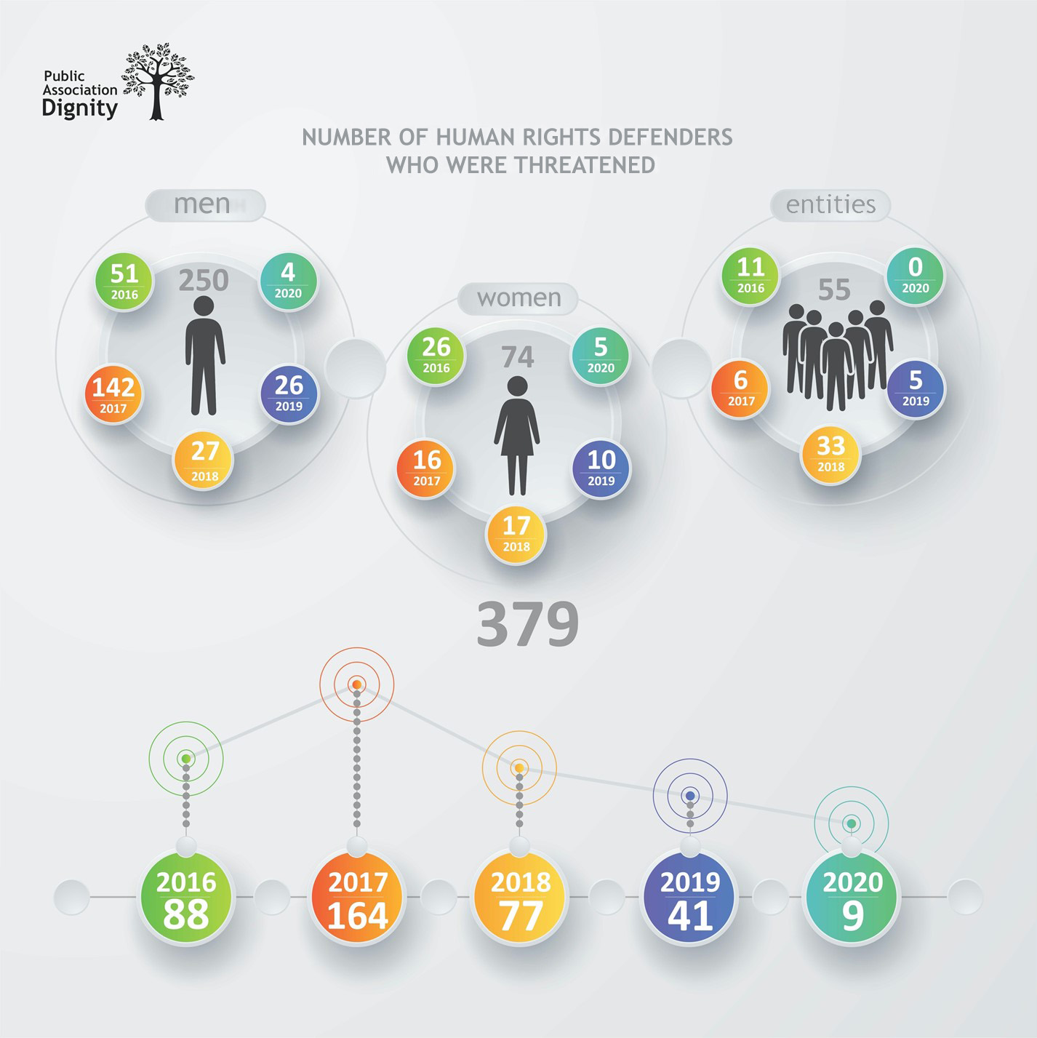
Activists who defend against business-related human rights receive 20% of the total number of threats addressed to all seven categories of human rights defenders and civil society activists.
Men were threatened more often than women.
Throughout the last five years, 2017 differs markedly. 164 human rights defenders received 377 threats in 2017 (352 in January alone), with the majority in January-March, June, September and December. On the other hand, comparing 2016 (109 threats) to 2017 (375), a number of persecutions increases more three times, while in general the number of threats decreases (by fields) by nine times between 2016 and 2020.
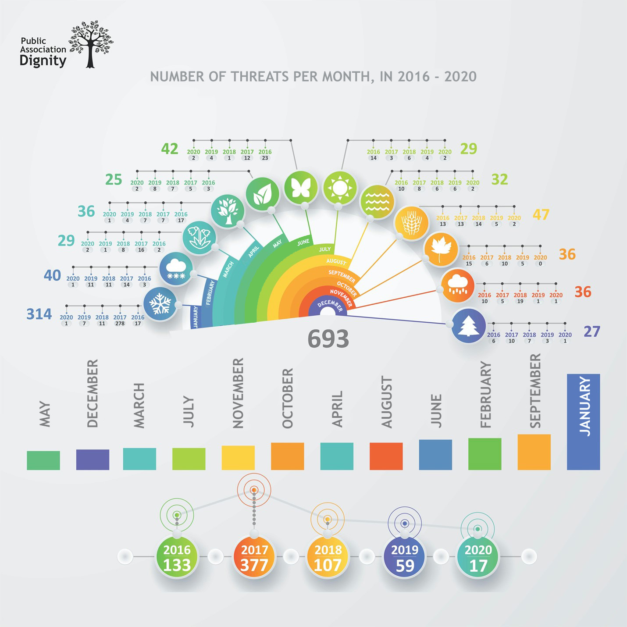
Analysis of indicators of the number of threats by years and months shows a direct relation between the level of civil society activity, protest mood, political, economic events in the country and the number of threats to activists. According to such criteria, 2016, 2017 and 2019 are remarkable; months in evidence are January (314), February (40), June (42) and September (47).
The trend that has been steadily observed over the past 10 years is characterized by the narrowing of the civil society field of action; public sector duplication (the creation of SONGOs [NGOs organized by the State] alongside with the existing independent groups); the gradual limitation of the activities of different categories of activists (the authors of the overview distinguish seven of them) until there is literally no political opposition in the country; and limitations of religious associations’ activists within two years (starting in 2011 with the adoption of amendments to the legislation on religious associations). The authorities ‘sorted out’ independent journalists in 2012, then in 2013-2018 followed the independent trade union activists. In 2016-2017, the authorities ‘addressed’ human rights defenders, in 2018-2019, lawyers and in 2018-2020, civil society activists.
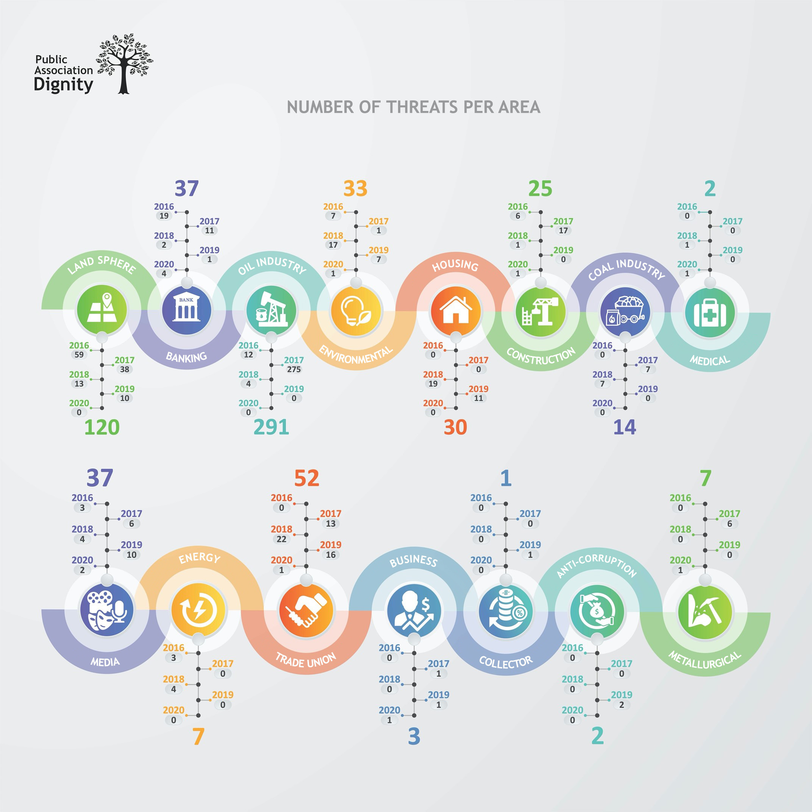
Out of the 15 identified fields, the following eight are leading:
- Oil industry (291 threats to 260 persons)
- Land (120 threats to 68 persons)
- Trade unions (52 threats to 34 persons)
- Banking (37 threats to 27 persons)
- Environment (33 threats to 27 persons)
- Housing (30 threats to 13 persons)
- Information (25 threats to 23 persons)
- Construction (25 threats to 8 persons)
It should be noted that, among the top three fields of threats, the land sector was leading in the first four years (2016-2019). In 2020, the banking and media fields took the lead.
- In 2016, the land sector prevailed with 59 threats to 45 persons, related to ‘land protests’
- In 2017, the oil industry led, with 275 threats to 246 persons caused by workers’ strikes
- In 2018-2019, the trade union field was most attacked, with 22 threats to 21 persons and 16 to 9, respectively, due to the amended legislation
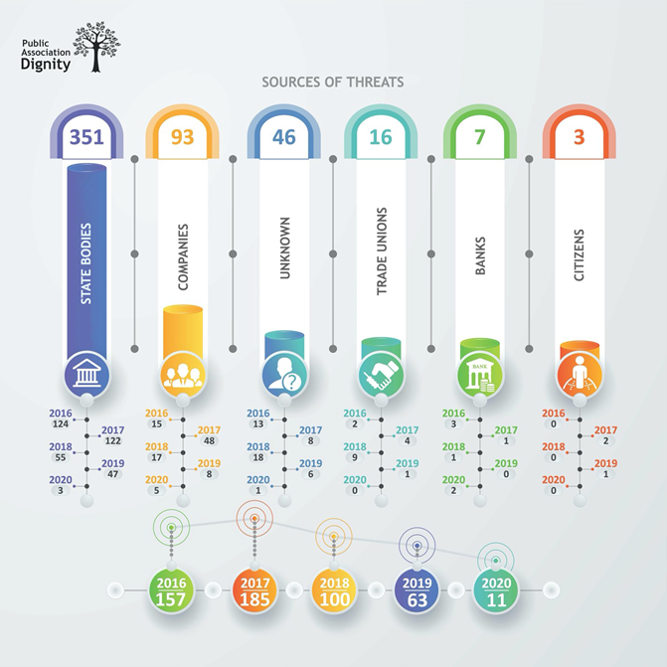
Among threat sources, the highest number of threats was from the State, companies and unknown persons in 2017 (185). From such State authorities, leadings sources were the police (137), the court (119) and the National Security Committee (25). The analysis of the data by year places the numbers in the following sequence: 185 (2017), 157 (2016), 100 (2018), 63 (2019) and 11 (2020). The number has decreased by more than 16.8 times. Over the same period the number of the State representatives in the capacity of sources of threats falls by 41 times and of companies by 3 to 10 times. The number of cases of threats, where such sources are banks, is stable over the past five years. It is possible to explain the situation by the change of the President in March 2019 (after June elections).
The companies most commonly found in monitoring are as follows:
- Batua 6 times
- ArcelorMittal Temirtau (AMT) 7 times
- Techno Trading LTD 10 times
- Oil Construction Company 19 times
According to human rights defenders’ opinion, private companies are involved in the persecution, and government agencies cooperate with them. In addition, the fact that it is not difficult for the law enforcement authorities to open a criminal case against human rights defenders raises certain concern among the latter. Among the sources of threats were also named unknown persons from whom human rights defenders received threats. Human rights defenders associate threats from the State revenue authorities with the Parliamentary elections held in January 2020.
‘Two of the three criminal cases brought against me involve clashes with large companies. One of them, from the quasi-government sector, is Otbasy Bank, previously called ZhilStroySberBank, and the second is BI Group, represented by Chairman Rakhimbaev.’
‘These are accusations of disseminating deliberately false information (Article 274 of the Criminal Code of the Republic of Kazakhstan), which I personally encountered, accusations of inciting social hatred. There are also a number of other articles that can be used against human rights defenders.’
‘I was summoned to the Regional Department of Internal Affairs, the Prosecutor's Office. They wanted to interrogate me, to film, suggesting that I was also a member of an unregistered public association.’
‘In 2018, the trade union leadership was prosecuted when hundreds of miners have begun underground strike. According to ArcelorMittal Temirtau, a civil case was brought against the leadership, but later their claim has been withdrawn. In my opinion, their decision was influenced by well-grounded statement of defence.’
‘They threatened my mother - she had a bank loan, so they tried to manipulate through the bank. Then they began to put pressure on my eldest daughter: police planted her drugs (anasha).’
‘We had everything: starting from the prosecutor’s checks, the financial police came, the tax inspectorate comes constantly. Once we publish a powerful statement or some other things, representatives of government agencies immediately come to us with a check. For example, we were conducting an advocacy campaign to change media legislation and when we made a statement that the amendments the government was making were completely inconsistent with international standards, the tax police came to our office without any charges, they just broke into the office, took all our documents, computers and began to pursue a case against us.’
The largest number of individuals subjected to threats are from Almaty (71 persons), Astana (Nur-Sultan) (38 persons), Aktau (34 persons), Atyrau (27 persons) and Mangistau region (20 persons). However, the geography of threats is slightly different; a greater number of threats were received in Nur-Sultan (96), Almaty (95), Atyrau (53), Aktau (48), Shymkent (39) and Mangistau region (26).
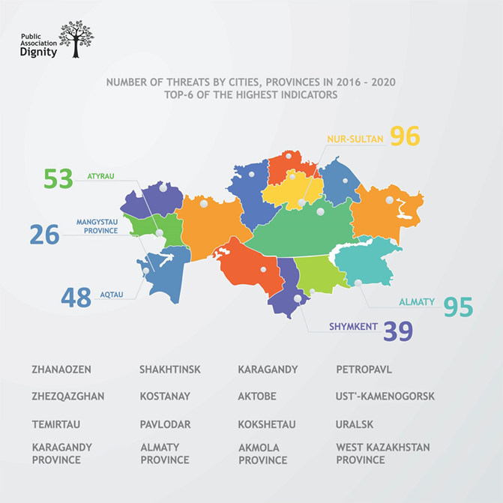
The number of persons was not determined by the population size, but it was influenced by the level of citizens’ activity in the indicated cities and regions.
When asked to provide examples of threats, to give a comparative assessment of the situation over the past five years and to draw a conclusion about changes, including those related to COVID-19, the interviewed human rights defenders noted a deterioration of their security; toughening restriction of the civil society activists’ activities have been observed. Among the most common risks, there are criminal prosecutions and suspension of activities. The narrowing of field of action of the human rights defenders is ‘justified’ by the pandemic. According to one point of view, the pandemic is an additional resource for the ‘legitimate’ suppression of human rights defenders’ activities.
‘In the banking sector it remained at the same level. I think it is due to the fact that there are a lot of borrowers with problem loans, and if human rights defenders begin to accumulate this force, it can become a threat. Therefore, in this area, there is not so much pressure on human rights defenders.’
‘These are accusations of disseminating deliberately false information (Article 274 of the Criminal Code of the Republic of Kazakhstan), which I personally encountered, accusations of inciting social hatred. There are also a number of other articles that can be used against human rights defenders.’
‘With recent events, we can say suspension of activities until further closure. If an organization conducts its activities at odds with the interests of the state, then - up to closure. The situation has deteriorated much, it has become much worse’.
‘We have learned how to work with Government agencies by means of correspondence. There is no pressure right now. The situation has improved over the past three years.’
The results of the conducted study outlined 5 blocks of types of threats:
- Different types of threats 41 types
- In criminal law proceedings 40 types
- In criminal-executive law proceedings 20 types
- In administrative law proceedings 9 types
- In civil law proceedings 6 types
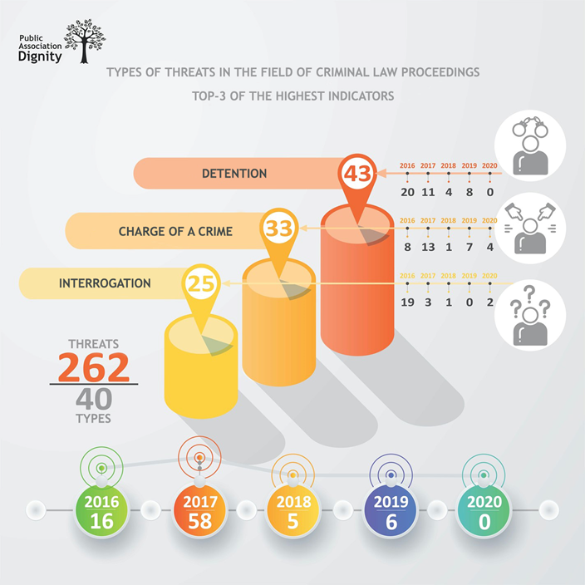
Major threats in criminal law proceedings (primarily received in 2016-2017), could be divided into seven types:
- Detention 43 instances
- Charge of crime 33 instances
- Interrogation 25 instances
- Police summons 18 instances
- Refusal of the court to satisfy motions, complaints, challenges 15 instances
- Guilty verdict 15 instances
- Rejection of the appeal 14 instances
The interviewees reported that they often faced criminal prosecution. Over the past five years, four out of eight interviewed human rights defenders have been both interrogated as witnesses and charged of a criminal offence. As a rule, this happens after vigorous activist activity. In addition, civil law cases are initiated to obstruct human rights defenders’ activities. Three charges of crime were launched against two human rights defenders under Article 274 of the Criminal Code of the Republic of Kazakhstan (‘Dissemination of deliberately false information’).
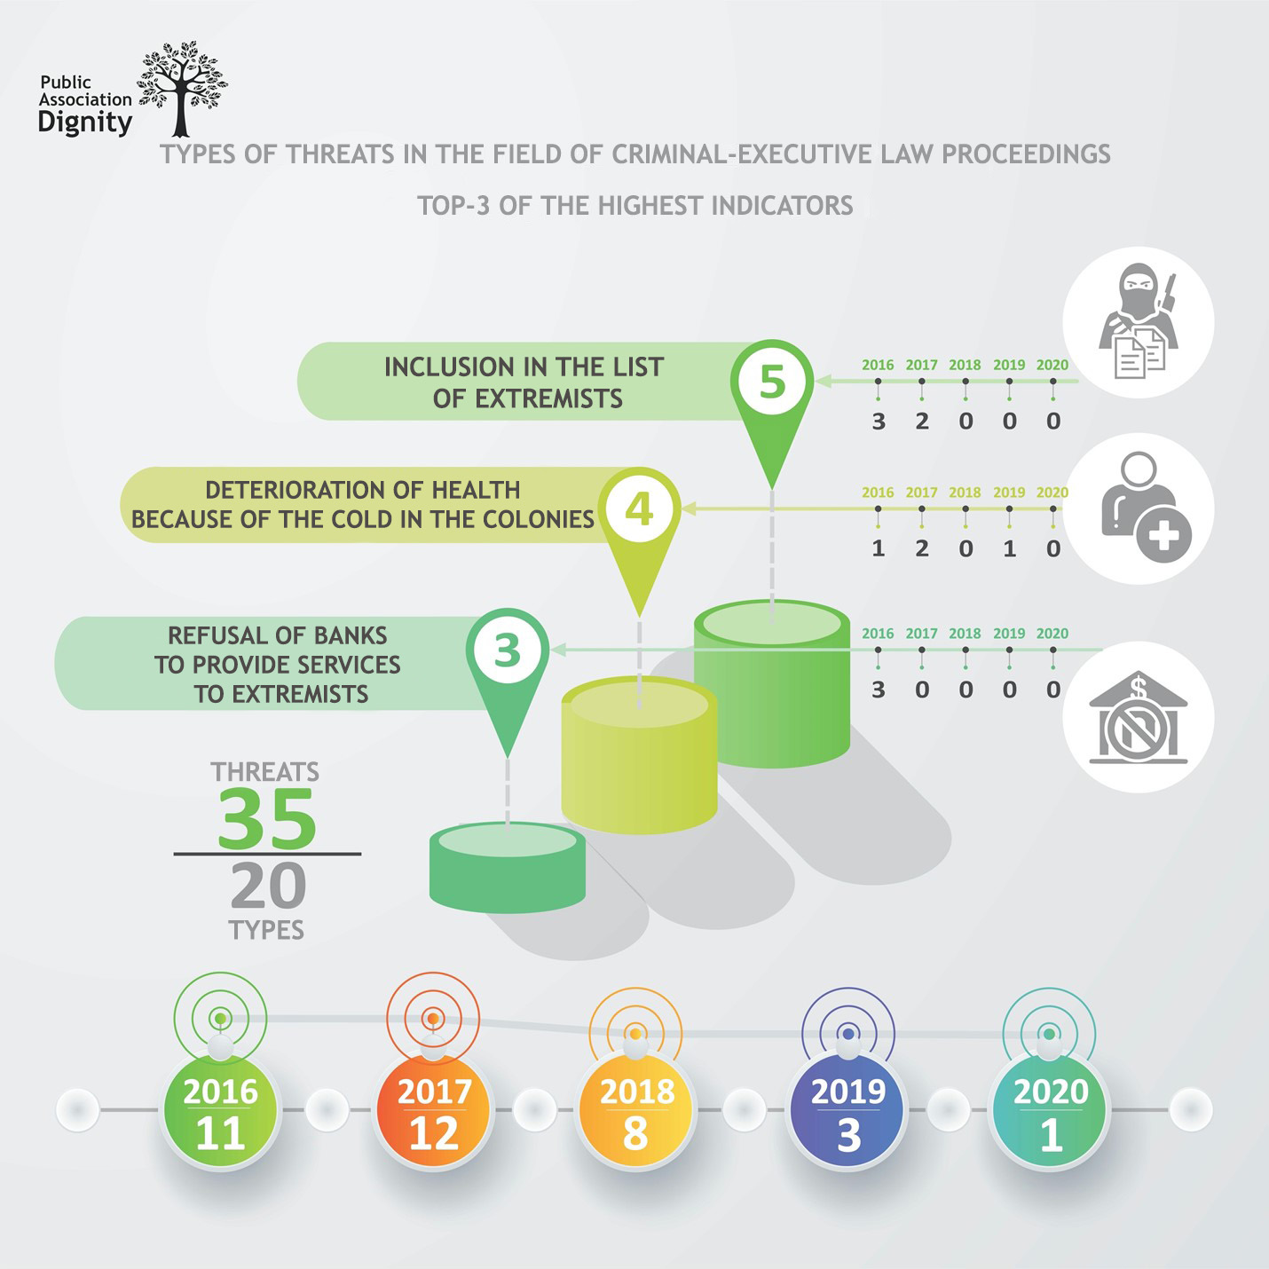
Two major threats in criminal-executive law proceedings (in 2016-2017) are:
- Registration in the list of extremists 5 threats
- Poor detention conditions in the KUIS (Penitentiary 4 threats
System Committee) facilities and health deterioration
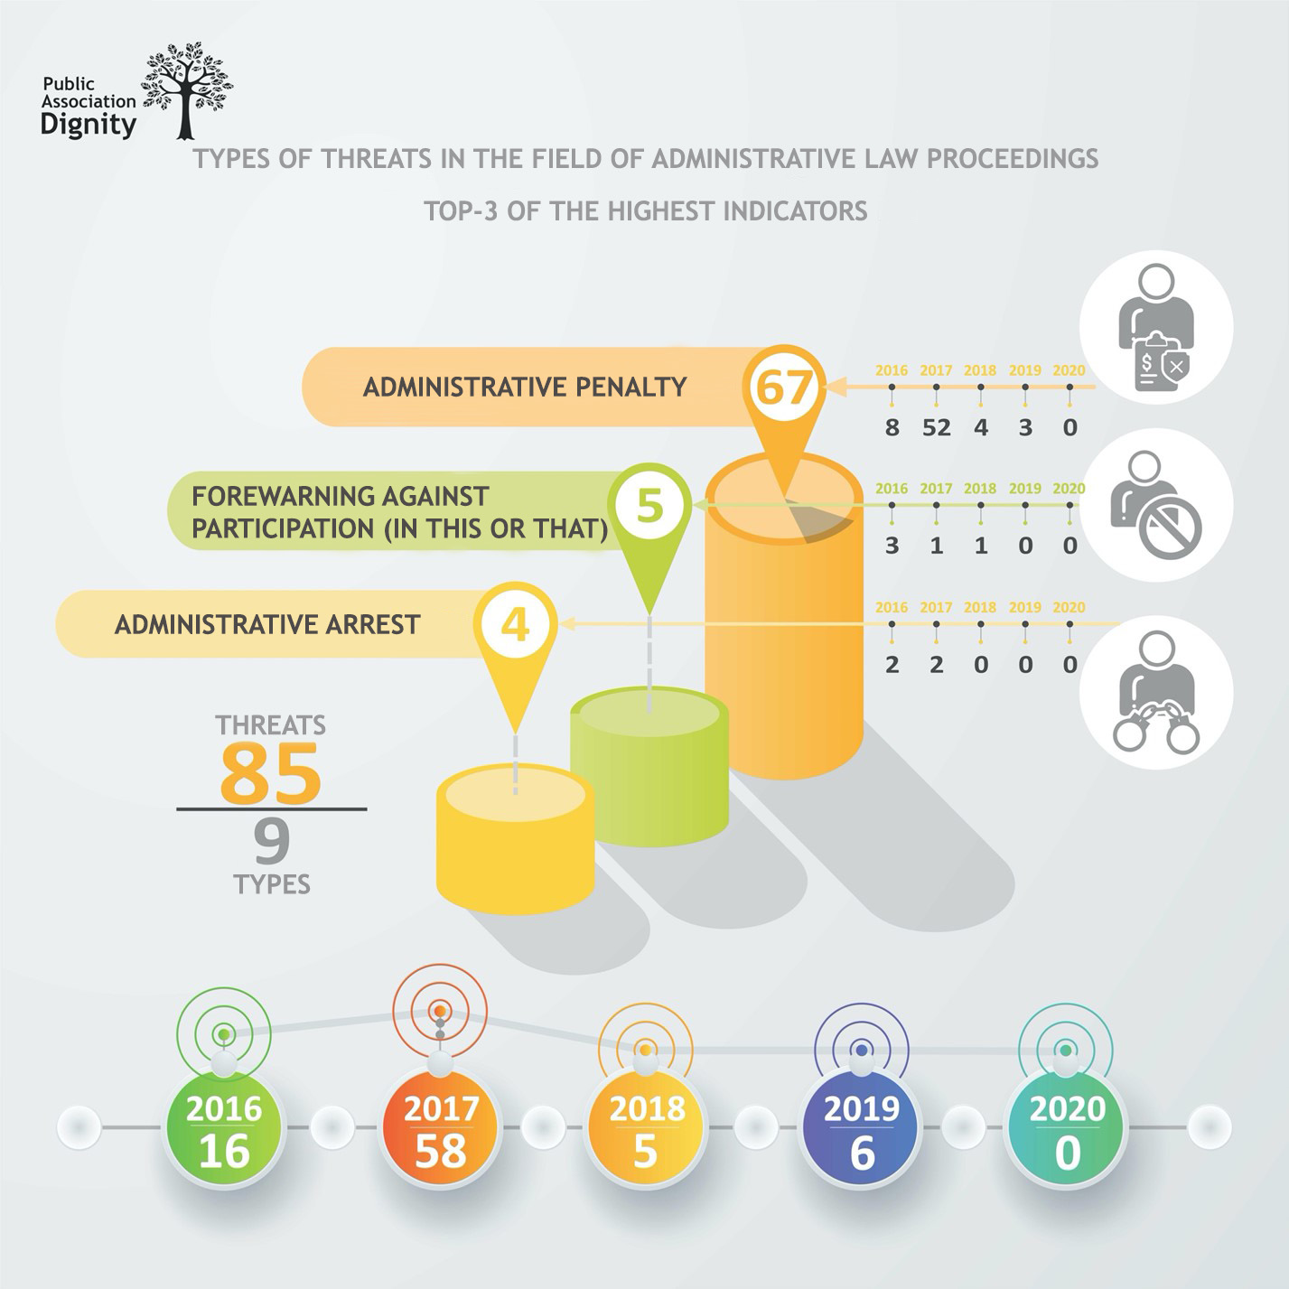
Two major types of threats in administrative law proceedings (primarily in 2017) are:
- Administrative penalties 67 threats
- Forewarnings 5 threats
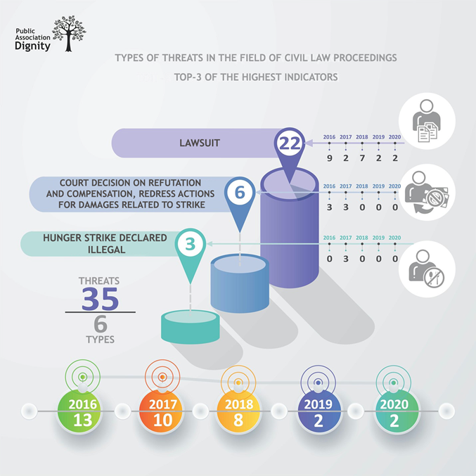
Two major types of threats in civil law proceedings (majorly in 2016-2017) are:
- Lawsuits 22 threats
- Court decisions on compensation for 6 threats
businesses reputation discreditation
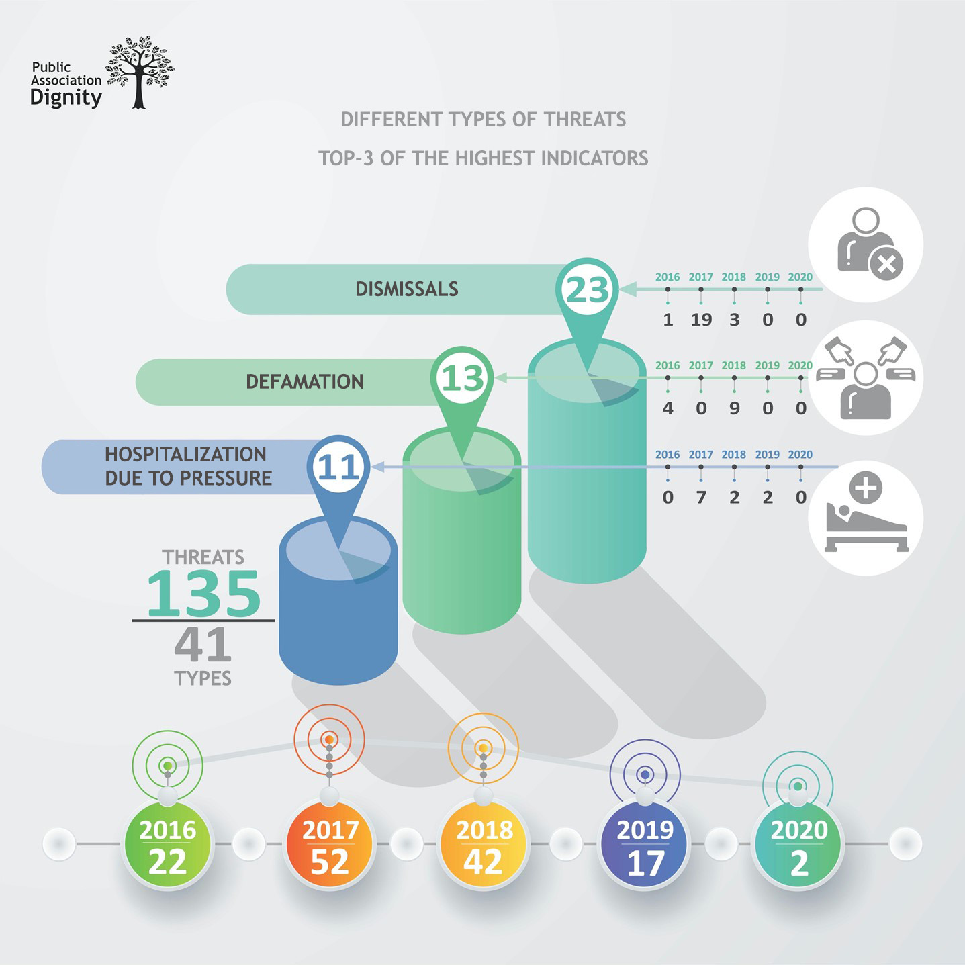
Among 41 different types of threats (majority in 2017-2018), there are three major areas:
- Dismissal 23 threats
- Defamation 13 threats
- Hospitalisation 11 threats

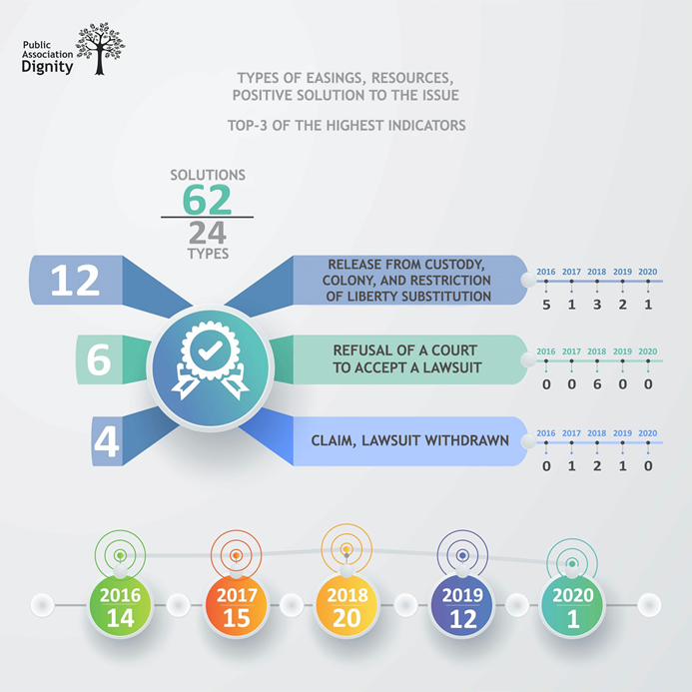
A positive resolution of situation has been recorded in favour of 44 activists, more often in 2018 (19 persons) and in 2017 (12 persons). Recourse occurred in 13 cities, mostly in Astana (10) and Temirtau (8). The positive consequences of measures taken in response to threats were evident in 62 cases; more often in 2018 (20 cases) and in 2017 (15 cases).
All interviewees reported that they always perceived the support of Kazakhstani NGOs, the wives of miners from German Federative Republic and the US Embassy. The Solidarity Charity Foundation, the Secretariat of the Aarhus Convention, the UN Human Rights Committee and the Transparency International were mentioned among the international organisations that supported the activists. The following media were mentioned as covering the attacks and persecutions: ‘Uralskaya Nedelya’ newspaper, ‘Radio Azattyk’, ‘Bakhytzhan Toregozhina’ and Al-Jazeera journalists. The respondents noted that in consequence to the reaction from NGOs, the pressure on human rights defenders always dropped.
When asked about businesses cooperating with civil society when concerns are raised about their operation, and requested to share some positive examples, the opinions of the participants were divided: four of them reported that private companies did not cooperate with civil society and human rights defenders. Three persons expressed the opinion that there were mechanisms, and ‘sometimes companies make contact, prioritizing proper interests, however they cooperate very rarely and only when compelled’. Two participants expressed the opinion that Chinese companies, unlike Western ones, did not cooperate with civil society and human rights defenders at all. No positive examples of cooperation between private companies and human rights defenders without any commercial interests were listed.
All interviewees responded that they had no knowledge of and never came across the situations in which private companies would support human rights defenders, invoking the fraught consequences for the organisations themselves in case of such support.
The majority opinion about the role of the Government and its support to human rights defenders was that such support ‘was not observed’. On the contrary, human rights defenders feel pressure from the Government. They referred, for example, to the new amendments to the Law ‘On Peaceful Assemblies’, since that actively counteracted the civil society activists. Obstacles were reported to the activities of trade unions by ignoring or not accepting registration documents by the Ministry of Justice and its field offices. Alongside with mentioning the existence of dialogue platforms for discussions between governmental authorities and civil society, they noted the inefficiency of such platforms.
‘In Public it [the Government] does support, behind the scenes – it does not.’
‘If we take our organization, I have not seen support from the State. It seems to me that our state does not help human rights defenders. Pressure occurs as soon as something goes beyond the interests of the State.’
‘At the moment there is no pressure. For example, a group of miners in late 2020 appealed to the Department of Domestic Policy on the issue of excessive working hours. We solved the problem of workers there.’
Selfless concern and altruism was the most popular answer to the question of what drives human rights defenders to their work, and whether such work contributed to achieving corporate accountability for human rights abuses. Some of the participants want to achieve respect for human dignity, someone else wants to solve human problems, for the others it has become a part of life; there are those for whom this is a way of self-expression, and those who fight not for themselves, but for the future of their children and grandchildren. When asked about the responsibility for offenses, the interviewees answered: ‘a drop of water wears a stone away’. They are convinced that human rights defenders’ activities restrain extreme impunity. It should be noted that in the answers of all participants, there is optimism and a desire to go forward.

Recommendations
Based on the obligations of the Republic of Kazakhstan to protect human rights as enshrined by the international law, the current survey made it possible to formulate the following recommendations:
To the Government, the Parliament and the Supreme Court of the Republic:
- Invite the UN Working Group on the issue of human rights and transnational corporations and other business enterprises for an official visit to Kazakhstan, as well as the UN Special Rapporteur on the situation of human rights defenders.
- Ensure that any measures taken to mitigate the economic impact of the COVID-19 pandemic take into account the interests of workers, especially those in the most difficult and vulnerable situations.
- Commit businesses entities to respect human rights in responding to the COVID-19 crisis.
- Strive to strengthen cooperation to meet the challenges of the pandemic.
- Recognize the facts of violations of human rights, as well as the rights of human rights defenders and civil society activists.
- Create a national mechanism for the protection of human rights defenders and civil society activists. Whistle-blowers of human rights violations must be protected from retaliation. Consider this situation through the prism of the rights to protection and freedom of expression.
- Take measures to eradicate threats to human rights defenders for their activities and investigate each case of threat.
- Ensure safe access for everyone to the procedures of complaint mechanisms in accordance with the UN Guiding Principles. Ensure that the admissible complaints include complaints about damage caused during the pandemic.
- Provide effective domestic remedies to each person and to human rights defenders, and provide adequate protection to victims of human rights violations.
- Ensure compliance with the requirements of the current legislation of the Republic of Kazakhstan by government officials, officials, companies and persons acting in an official capacity. Furthermore, the law should be equally applied to everyone.
- Respond quickly to the business-related human rights crisis, taking into account the impact on the needs of vulnerable groups.
- Fulfil international human rights obligations. For example, along with the key obligations under the ratified human rights treaties, designate the responsible bodies for the development and operation of State and non-State-based grievance mechanisms with a basic level of effectiveness in line with the Guiding Principles. (For recommended actions, see OHCHR Reports on Accountability and Remedies.)
- Eliminate social injustice.
- Create conditions for human rights defenders to exercise their rights and freedoms.
- Ensure that companies adhere to the principles of openness and transparency, strict observance of the current legislation of the Republic of Kazakhstan, a tough response to violations and immediate measures to protect human rights.
- Fulfil obligations in creating conditions for the registration and activity of trade unions.
- Learn to be open to criticism from the part of civil society.
- Conduct a constructive dialogue with civil society. Transform existing dialogue platforms for discussions between the State and civil society into an effective tool.
- Strengthen global partnerships, as well as promote and advance human rights by providing resources, knowledge and forward-looking ideas on the creation of new systems for the transition to a more sustainable future.
To companies, corporations and entrepreneurs:
- At all stages of their activities, fully ensure respect for and promote the implementation of human rights and freedoms in the Republic of Kazakhstan established by the international treaties and the current national legislation.
- Be responsible for respecting human rights during the COVID-19 period. Know and demonstrate that all reasonable measures have been taken to prevent and mitigate the impact of COVID-19 in the field of human rights. (For example, respect the rights of employees; implement a human rights due diligence policy; identify, prevent and mitigate the harm from violations; and report on measures to reduce negative human rights impacts during the pandemic.)
- Conduct meaningful consultations and cooperate with human rights defenders and potential affected groups. Pay attention to specific impacts on individuals who may be at risk of vulnerability and marginalisation.
- In case of adverse impact of the company, actively participate in compensation for damage.
- Abandon (if any) the practice of coercion to work in unsafe conditions, of illegal dismissals and/or of harassment of trade union leaders and activists.
- Ensure openness and transparency, as well as access of human rights defenders to truthful information of public interest. Regularly hold press conferences and briefings on the observance of workers’ rights in companies.
- Conduct research with the participation of human rights defenders and civil society activists. Publish reports on measures of collaboration with civil society and respect for human rights and freedoms.
- Provide answers to inquiries from public organisations about the human rights situation in their companies within the time frame established by the current legislation of the Republic of Kazakhstan.
- Conclude memorandums of cooperation with human rights organisations willing to exercise public monitoring in the field of business and human rights.
To civil society and citizens:
- Show solidarity and support human rights defenders and activists, including those under threat.
- Conduct public investigations into cases of threats to activists.
- Participate in monitoring the situation of respect for human rights by companies, as well as relevant Government responses.
To international organizations and the global community:
- Require the State and companies to comply with the international obligations assumed by Kazakhstan.
- Carry out constant monitoring of the human rights situation, while helping individual citizens to solve their problems in compliance with the rule of law.
- Disseminate information and also attract international attention.
- Encourage the State to investigate into cases of threats to human rights defenders and to identify the civil society activists involved in the persecution.
- Conduct own investigations into cases of threats to activists.

ANNEXES
Companies’ replies to the inquiries by the Public Association ‘Kadir-Kasiet’
‘Kazakhmys Energy’ LLP reported:
‘The labour relations with A.T. Makhatova were terminated by agreement of the parties on the basis of the personal statement of the employee (at will). For the period from 2016-2020 on the initiative of the employer 1 employee was dismissed (on May 2, 2017, the employee of the Zhezkazgan Power Plant Nurgazin B.Kh.). For the period from 2016-2020 1 labour dispute arose between the employees and the employer (employee of Zhezkazgan Power Plant Nurgazin B.Kh.). In order to prevent labour disputes, all measures are taken to comply with the labour legislation of the Republic of Kazakhstan.’
KPO (The Karachaganak Venture) reported:
‘1-2. KPO works in close cooperation with Government environmental authorities and the local community. 3. ... the officials of the Republic of Kazakhstan announced that in the result ... of the investigation no facts, indicating that any emissions from the production activities of KPO caused the malaise among the students of the school in the village of Berezovka at the end of November 2014, were revealed. In March 2018, the case was closed by the Ministry of Internal Affairs of the Republic of Kazakhstan for the absence of corpus delicti. 4. All indicators of the company’s activities (production, environmental, social), etc. are available to the public on the KPO corporate website www.kpo.kz and in the annual Sustainability Reports published on https://kpo.kz/filesadmin/user_upload/files_2020/Otchet_ob_ustoichivom_razvitii_KPO_2019.pdf. 5. KPO, adhering to the principle of corporate social responsibility, pays special attention to supporting vulnerable groups of population in the rural districts located closest to the mineral deposit. In particular, the following projects are implemented annually for the residents of these districts: sanatorium for retired; summer vacations for children in a children’s camp; grants and scholarships program.’
‘Oil Construction Company’ LLP reported:
‘The legal assessment, legality, reasons and consequences of the actions of the Company employees to hold a hunger strike in 2017 were determined by the relevant authorized and judicial authorities of the Republic of Kazakhstan in accordance with the established procedures.’
JSC ‘Housing Construction Savings Bank ‘Otbasy Bank’ reported:
‘Information regarding the Bank’s appeals to the law enforcement authorities for conducting a pre-trial investigation is confidential and is not subject to disclosure in accordance with the requirements of the criminal law procedure of the Republic of Kazakhstan.’
‘Techno Trading LTD’ LLP reported:
‘LLP cannot answer the questions due to the confidentiality of this information, aimed at maintaining social stability in the team.’
‘ArcelorMittal Temirtau’ JSC reported:
‘.... due to the fact that the strike of the employees of the Coal Department have been covered in the media and the JSC has given comments during that period, we consider it inappropriate to provide any further answer and participate in the proposed survey. Your request contains incorrect information regarding the events that aroused your interest.’
‘BozashyTransKurylys’ LLP reported:
‘In 2017, the LLP did not file any applications on interference of the Confederation of Independent Trade Unions of Kazakhstan with the work of the company. We also inform you about the absence of labour disputes between organizations.’

Reference
All of the abovementioned companies are legal entities and information holders with obligations: to provide access to information, to provide reliable and complete information, to conduct internal control over the quality and timeliness of the provision of information, etc. Akims are obliged to report to the public on the accomplished work.
According to Article 4 of the Law of the Republic of Kazakhstan ‘On Access to Information’, ensuring access to information is based on the following principles:
- Legality
- Openness and transparency of information holders’ activity
- Credibility and fullness
- Actuality and timeliness
- Equal access to information
- Personal privacy, personal and family secrecy
- Observance of rights and legal interests of individuals and legal entities
An answer to a written request shall be provided within 15 calendar days from the date of receipt to the information holder (Paragraph 10 of Article 11 of the Law of the Republic of Kazakhstan ‘On access to information’).

This document was endorsed by the UN Human Rights Council on June 16, 2011. https://www.ohchr.org/Documents/Publications/GuidingPrinciplesBusinessHR_RU.pdf
According to Paragraph 3, Article 6 of the Constitution of the Republic of Kazakhstan, ‘The State shall own the land and underground resources, waters, flora and fauna, and other natural resources. The land may also be privately owned on terms, conditions and within limits established by law’.
Including the Constitution, civil, customs and tax legislation, Laws, Presidential Decrees and other legal acts on business and economic activities, on land, on privatization, on subsoil and subsoil use, on oil, on banks and banking, on insurance, etc.
Article 2 of the Declaration on the Right and Responsibility of Individuals, Groups and Organs of Society to Promote and Protect Universally Recognized Human Rights and Fundamental Freedoms (Declaration on Human Rights Defenders). Adopted by General Assembly resolution 53/441 on December 09, 1998 https://www.un.org/ru/documents/decl_conv/declarations/defender.shtml
By virtue of Article 7 of the Republic of Kazakhstan Law ‘On Access to Information’, the information user has the right to receive and disseminate information, apply for information, verify the reliability and completeness of the information received.
The inquiries of PA ‘Kadir-Kasiet’ were sent to the most frequently mentioned in the monitoring, or to the largest companies: - Oil Construction Company LLP No. 10/21 dated February 1, 2021 - Federation of Trade Unions of the Republic of Kazakhstan No. 11 dated February 2, 2021 - Techno Trading LTD LLP No. 12 dated February 3, 2021 - Kazakhmys Energy LLP No. 13 dated February 3, 2021 - Burgylau LLP No. 14 dated February 3, 2021 - Kentech Kazakhstan Technical Services LLP No. 15 dated February 3, 2021 - ArcelorMittal Temirtau JSC No. 20 dated February 5, 2021 - KPO No. 22 dated February 9, 2021 - BI Group, No. 23 dated February 12, 2021 - Otbasy Bank JSC No. 26 dated February 12, 2021 - BozashyTransKurylys LLP No.27 dated February 12, 2021 - WestOil
ArcelorMittal Temirtau JSC – verbally reported that ‘the person in charge is away’ - BI Group – asked to call back, but never answer the phone - Burgylau LLP – verbally reported that they would not respond to the letter of PA ‘Kadir-Kasiet’ - WestOil – verbally explained that ‘the director is away, the letter has not been opened yet’ - Kentech Kazakhstan Technical Services LLP – all numbers available on the Internet do not answer the phone - Federation of Trade Unions of the Republic of Kazakhstan – verbally replied that they would send a response
https://www.ohchr.org/Documents/Publications/GuidingPrinciplesBusinessHR_RU.pdf
https://www.ohchr.org/Documents/Publications/Principles_ResponsibleContracts_HR_PUB_15_1_RU.pdf
https://www.ohchr.org/RU/Issues/Business/Pages/InternationalStandards.aspx
https://www.ohchr.org/ru/Issues/Business/Pages/BHR_Reports.aspx
https://www.ohchr.org/RU/Issues/Business/Pages/WGHRandtransnationalcorporationsandotherbusiness.aspx In June 2011 (resolution 17/4), the Human Rights Council established this Working Group.
https://www.ohchr.org/RU/HRBodies/HRC/WGTransCorp/Pages/IGWGOnTNC.aspx The mandate of the Working Group shall be to elaborate an international legally binding instrument to regulate, in international human rights law, the activities of transnational corporations and other business enterprises. The Group held 5 sessions.
In 2016 - 292 threats, in 2017 - 487 threats, in 2018 - 489 threats (577 persons), in 2019 - 733 threats (511 persons), in 2020 - 1414 threats (685 persons).
In 2016 - 133 cases, in 2017 - 377, in 2018 - 107, in 2019 - 59, in 2020 - 17.
Positively resolved cases are considered ‘resources’, for example: release from custody, cancellation of a judicial act, rejection of a claim, acquittal, return of confiscated gadgets, registration of a trade union, etc.
250 men, 74 women, 55 legal entities.
142 men, 16 women and 6 legal entities.
In 2016, there were 133 threats, a larger number in January, April, June-November; 107 cases of threats in 2018 with majority in January-February, September and November; 59 in 2019, of which 11 in February. In 2020, 17 cases of threats were recorded, 1-2 monthly.
Land, banking, oil industry, environment, housing, construction, coal industry, health care, information, energy, trade unions, business, tax collection, anti-corruption, metallurgical.
Out of 516 sources of threats over 5 years: government agencies - 351, companies - 93, unknown persons - 46, banks - 7, public organizations - 16, citizens - 3.
In 2016 - 60, in 2017 - 38, in 2018 - 55, in 2019 - 47, in 2020 - 3.
In 2016 - 24, in 2017 - 58, in 2018 - 18, in 2019 - 19, in 2020 - 0.
In 2016 - 21, in 2017 - 4, in 2018-2020. - 0.
Considering the highest value for any of the previous years and 2020.
In 2016 - 9, in 2017 - 13, in 2018 - 19, in 2019 - 9, in 2020 - 1.
The Human Rights Bureau and the PA ‘Kadir-Kasiet’ were mentioned twice.
Mr. Dante Pesce (Chairman since January 1, 2021) (Chile), since 2015. Mr. Surya Deva (Vice-Chairman since January 1, 2021) (India), since 2016. Mr. Githu Muigai (Kenya), since 2018. Ms. Elżbieta Karska (Poland), since 2018. Ms. Anita Ramasastry (USA), since 2016.
From human rights defenders’ interviews: ‘First of all, to attract attention, raise issues and keep the state bodies of the Republic of Kazakhstan in good shape, stimulate them to solve problems. At the same time, it is very important that attention from international organizations helps specific citizens of the Republic of Kazakhstan to solve specific problems, and not just be limited to another report “how bad everything is” in the country. This also applies to human rights defenders who are at the forefront of protecting the rights of citizens.’ ‘To monitor the situations, to protect the citizens’ interests.’ ‘It is necessary to impose sanctions in relation to those persons who are associated with the persecution and pressure of human rights defenders and civic activists. Block accounts, property abroad. Then there will be a result. Only punishment to the full extent of the law will be clear to them.’ ‘First of all, to make information public, open, objective. Publicity is always feared. Conduct your investigations.’ ‘First, they disseminate such information. Secondly, international organizations, I know, provide assistance. Only the fact that they are protesting and doing their job is also a support. I know that they respond to every illegal arrest and detention. I know that they provide assistance, do everything possible to support human rights defenders. And I do not know what else they could do.’ ‘Unfortunately, practically all the statements of international organisations that deal with political problems remain unanswered, but the organisations that deal with economic affairs – problems of investing or issuing loans, always receive attention from the State.’
Reply of Kazakhmys Energy LLP dated February 11, 2021, No. 01-9-1/148 signed by the Technical Director K.A. Kazhkenov.
Reply of KPO dated February 25, 2021, No. KZO-0243-21, signed by General Director E. Blom.
Reply of Oil Construction Company LLP dated February 9, 2021, No. 04-0292 signed by Deputy General Director A. Salmanov.
Reply of JSC House Construction Savings Bank Otbasy Bank dated March 2, 2021, No. 09 / 1-16-07 / 4653 signed by the Deputy Chairman of the Board of Directors M. Beisembayev.
Reply of Techno Trading LTD LLP dated March 4, 2021, No. 397 signed by the Director V.B. Koshumbayev.
Reply of ArcelorMittal Temirtau JSC dated March 9, 2021, No. 633 signed by HR Director V.V. Tereshkina.
Reply of BozashyTransKurylys LLP dated March 2, 2021, No. 10-07-176 signed by the Director E. Kengan.

