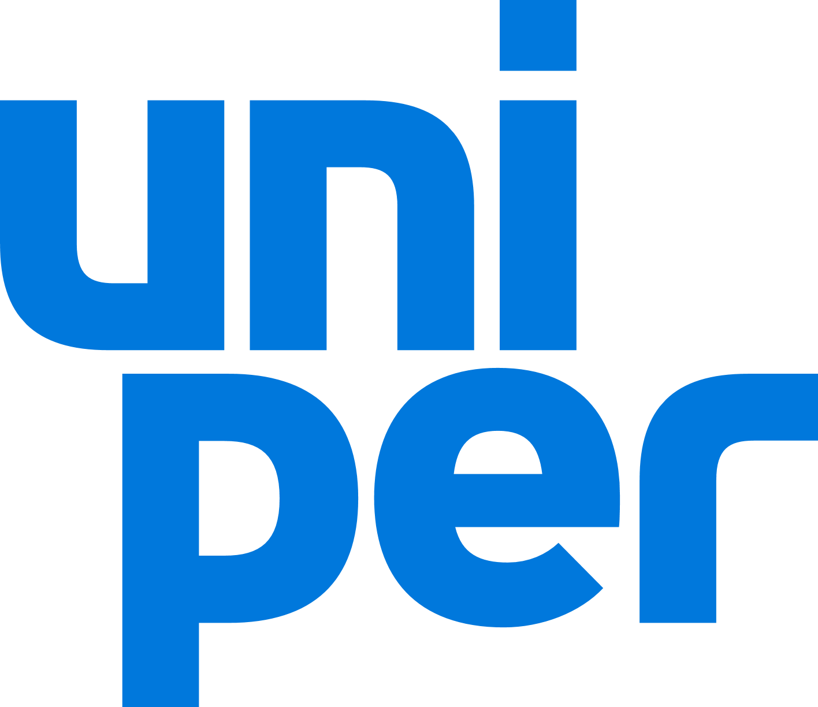
17.03.2022

Unipers respond to: Ukraine & Russia human rights due diligence survey

For companies operating or investing in Russia

Nature of involvement
1. How long has your company or subsidiary been operating or investing in Russia? In summary, can you briefly describe the nature, sector, scale, and geographic area of these operations or investments?
- E.ON bought a 69.3% stake in OGK4 in 2007, rebranded to E.ON Russia in 2011. After the spin-off of Unipro (from E.ON) E.ON Russia was rebranded to Unipro.
- At the end of last year, Uniper started a divestment process of Unipro. Due to the current situation, this process has been halted for the time being and will be restarted as soon as it is feasible.
- Further information about Unipro: Company Profile - Unipro
- Uniper's gas midstream business comprises a portfolio of around 370 TWh of long-term gas supply contracts: Of these, about 200 TWh originate from Russia.
- Uniper sees it as its mission to do everything in its means to supply people in Germany and Europe with energy, also and especially in these volatile times. Uniper will continue to be reliable in fulfilling this task on the basis of the existing contracts.
- Uniper will not enter into new long-term supply contracts for natural gas with Russia.

Assessing Risks
2. How is your company enhancing its due diligence to identify, prevent, and mitigate heightened human rights risks and comply with international humanitarian law?
- Uniper continuously assesses ESG risks that could arise from its operations through its systematic due diligence process. ESG risk management is part of our overall enterprise risk management. Uniper has measures in place to control, minimize, and mitigate the ESG risks it identifies.
- Uniper’s due diligence directive is aligned with the UN Guiding Principles on Business and Human Rights (2011), the OECD Guidelines on Multinational Enterprises (2011), and relevant implementing documents, to embed responsible business conduct into policies and management systems. We took several steps for the process: ESG due diligence check through desktop analysis; tailored in-depth analysis of ESG issues; agreement on adequate mitigation measures with the Contract/Project Owner to prevent and minimise the identified material ESG risks; and Monitoring phases, including regular checks of the counterparty ESG risk level and progress of the mitigation measures implementation.
- Its purpose is to define the right prevention and mitigation measures for each of them and to advise the Uniper Board of Management accordingly. The objective is to avoid doing new business with counterparties causing or contributing to ongoing and severe adverse impacts on ESG issues, including human rights.
- In case of existing relations with counterparties which might cause, contribute or be linked to ongoing and severe adverse impacts on ESG issues, the implementation of timely and adequate mitigation measures is of paramount importance.
- All counterparties in scope of this process are assessed on a quarterly basis. Automated alert systems allow us to be notified in case the risk profile of individual counterparties changes significantly. In case of any major event with regional or even global magnitude, additional and proactive risk assessments are undertaken, both in terms of Crisis Management and ESG Risk Management process.
- In terms of ESG risk management, Uniper has an ESG Task Force in place, a cross-functional steering group whose purpose is to ensure that non-financial risks are identified, assessed, and mitigated. Dedicated desktop analysis, based on credible media and civil society reports, is prepared, validated by consensus of the ESG Task Force members and the results are shared within the functions which shall contribute to the mitigation efforts.

a) What measures is your company taking to ensure it relies and acts upon robust monitoring of the situation, including through consultation with your workers, affected communities, human rights groups, and/or humanitarian organizations?
- Respect for human rights is embedded in the way Uniper does business, in our Code of Conduct. We respect, protect and support internationally recognized human rights across all our business activities, in accordance with the Universal Declaration of Human Rights and the ILO Declaration on Fundamental Principles and Rights at Work.
- Open and regular dialogue with workers, affected communities, human rights groups and other civil society organizations is our preferred approach. This also relates to our business in Russia though we experience challenges in exchanging with stakeholders since the war in the Ukraine has started.
- Generally speaking, workers relations are supervised within the Group Works Council and specific ESG topics are discussed in a cross-functional committee that meets biannually. Workers are also involved in dialogues in case of strategic developments: for example, when Uniper decided to end generation at its Ratcliffe-power station (UK) at the end of September 2022, employees on site and recognised Trade Unions were briefed to discuss also the future plans. We’ve been working closely with stakeholders from across the region, including the Midlands Engine, local councils, Local Enterprise Partnerships, universities and business to understand how the Ratcliffe site can be part of continued economic growth in the East Midlands. This is part of our engagement process with communities nearby our assets or potentially affected by new projects. Transparent engagement with municipalities and other stakeholders is often required by law, particularly in case of new infrastructure projects. Nevertheless, our goal is to always inform our local stakeholders and address any concern related to potential environmental and social impacts.
- In relation to human rights issues along our supply chains, since 2019 we have committed to conducting, at corporate level, at least three new trust-building dialogues with civil society organizations each year. This allowed us to discuss and follow the development of some human rights impacts in various locations across the world where Uniper sources energy commodities.
- Last but not least, at Uniper we are committed to fostering a culture where our employees feel safe to speak up and report any potential infractions against the Code of Conduct and other violations of law or internal company policies. That is why we have an internal and an external whistleblower hotline where anyone who becomes aware of a breach can report it – also anonymously. Both ways of reporting are equally available to all third parties.

Mitigating risks and tracking effectiveness
4. If your company or subsidiary chooses to continue operating in Russia, what human rights due diligence has been undertaken and how are you planning to mitigate harm in Ukraine?
- Uniper condemns the Russian invasion of Ukraine in the strongest possible terms. With this war, Russia is breaking international law and the principles of the UN Charter.
- The ESG task force has prioritized the risks for Uniper and for our operations with specific counterparties due to the ongoing events. As first step, Uniper will not enter into new long-term supply contracts for natural gas with Russia. In the short term, we are aware that existing and significant business relations with companies providing financial means to the Russian government could be seen as indirect contribution to the ongoing situation in Ukraine.
- Taking in consideration also that we cannot discontinue the gas supply to Germany and other countries in the EU, we acknowledge there is no practicable way – as individual company – to influence the ones causing the negative impacts on civilians, but only to mitigate harm at the moment. For this reason, Uniper and Fortum have together donated so far €400,000 to the Red Cross for humanitarian aid in Ukraine. Additional funds were provided by individual subsidiaries in Sweden, Germany and Netherlands to other organizations.
- To help alleviating the suffering of the people in Ukraine and of the refugees, Uniper matches our employees private donations with our “matched donations” initiative. We will match the amounts all Uniper colleagues donated privately and donate the total centrally to the Red Cross.
- Additionally, in cooperation with local organizations, we provide a total of 30 Uniper-owned apartments in German locations to house refugees and coordinate related donations in kind and renovation / cleaning work.
- Other local and regional aid activities, e.g., the provision of medical supplies such as stretchers, medical masks as well as Covid tests, or the provision of a company van to an employee for taking part in a supply convoy make us proud of our employees and their willingness to help.

5. What kind of due diligence measures does your company use to ensure that it does not have any business relationships with sanctioned Russian individuals and entities? Beyond sanctions compliance, how does your company ensure that it does not have any business relationships with individuals or entities with a track record of rights violating conduct?
- To avoid such kind of risks, Uniper has a Group-wide Compliance Management System (CMS) in place since January 1, 2016
- We define compliance risks as the possibility of major legal proceedings, monetary fines, and damage to our reputation. These may result from misconduct or violations of laws and regulations, either from actions by our staff or by third parties acting on our behalf.

Exercising leverage
- 6. How does your company intend to use your leverage to protect the rights of your workers and communities affected by your operations in Russia, including freedoms of association and expression?
- Uniper is majority shareholder of Unipro. Unipro is operating at the Russian market of distributed generation and engineering as well and operates independently in Russia.
- 7. Is your company providing any support to Russian activists who are taking action against the war and in support of democracy and peace in Ukraine?
  - No.

Uniper SE
Holzstraße 6
40221 Düsseldorf

mail@uniper.energy
www.uniper.energy

