Responses to Land Inequality Briefing for Business
Reference to the Ocho Sur Group
Allegations in quotes and our responses in blue and in the embedded objects.

Below the points highlighted by my communications team that we are going to clarify to you:

“For more than seven years, the Shipibo-Konibo community of Santa Clara de Uchunya in the Ucayali region of Peru has been struggling to protect and reclaim their lands in the face of spiralling deforestation, oil palm expansion and attacks and violence. Now, new evidence shows how palm oil produced on their traditional lands without their consent is being traded by one of the world’s biggest agribusiness companies.”

False. Ocho sur is not using or producing palm oil in land of any native community including Santa Clara de Uchunya. There is no factual evidence, court ruling, anthropologic study, nothing that supports that statement except for false claims promoted by biased ONG whose business is to profit by fabricating non-existing conflicts.

Attached a copy of the letter submitted by the same Santa Clara de Uchunya community (executed by its members) to LOUIS DREYFUSS regarding the fake article that you are making reference in you Ednotes.

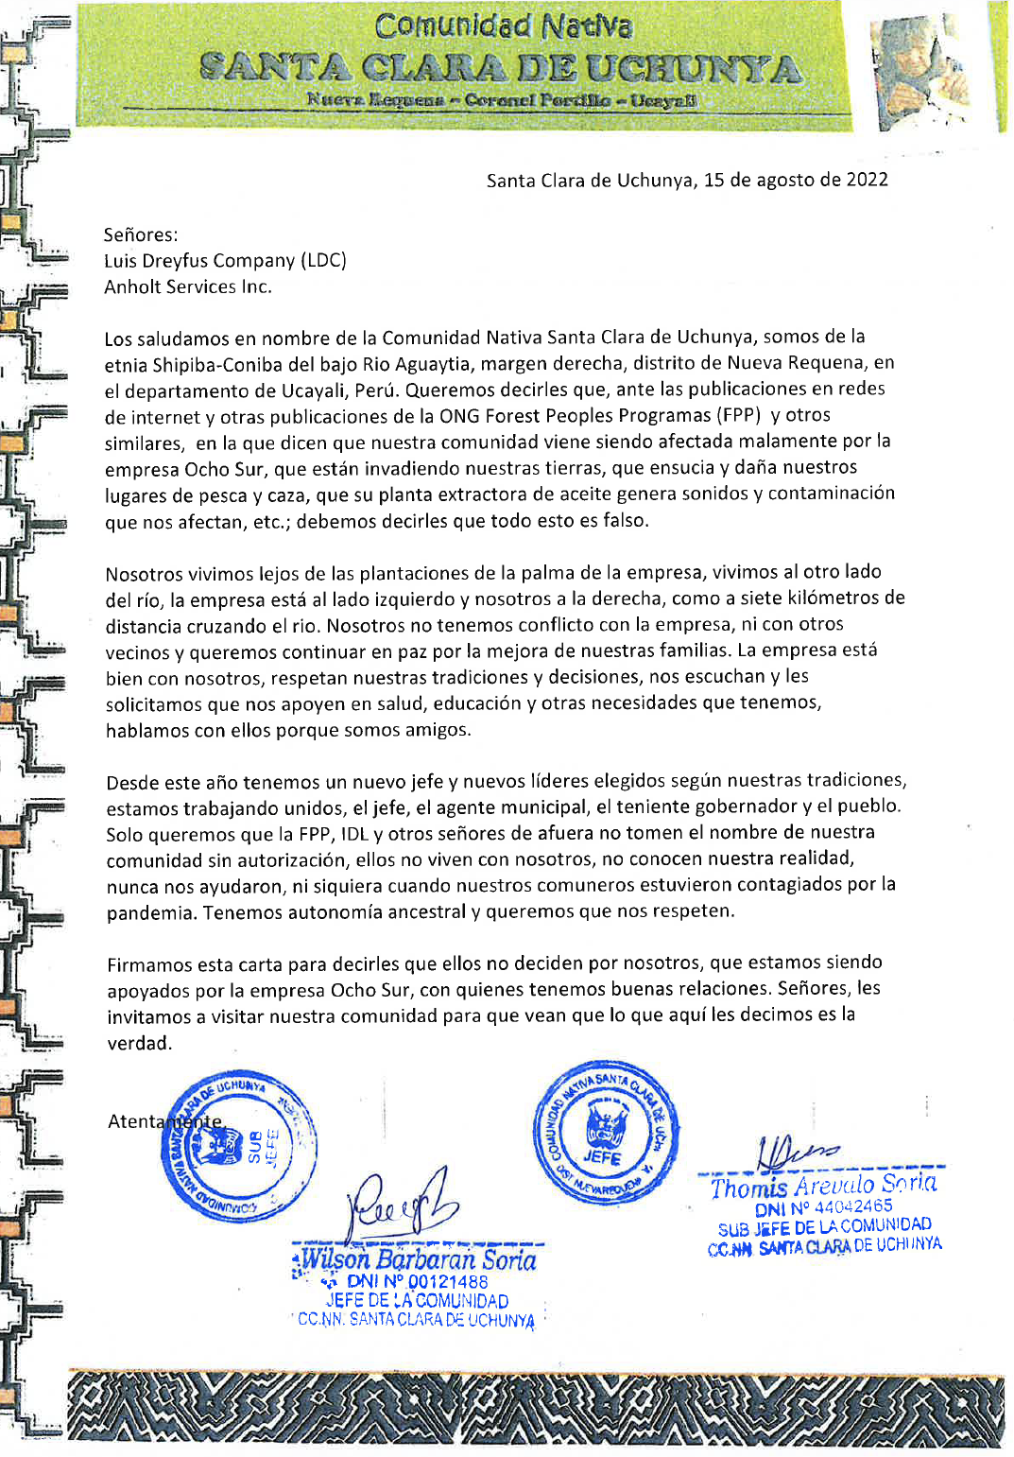
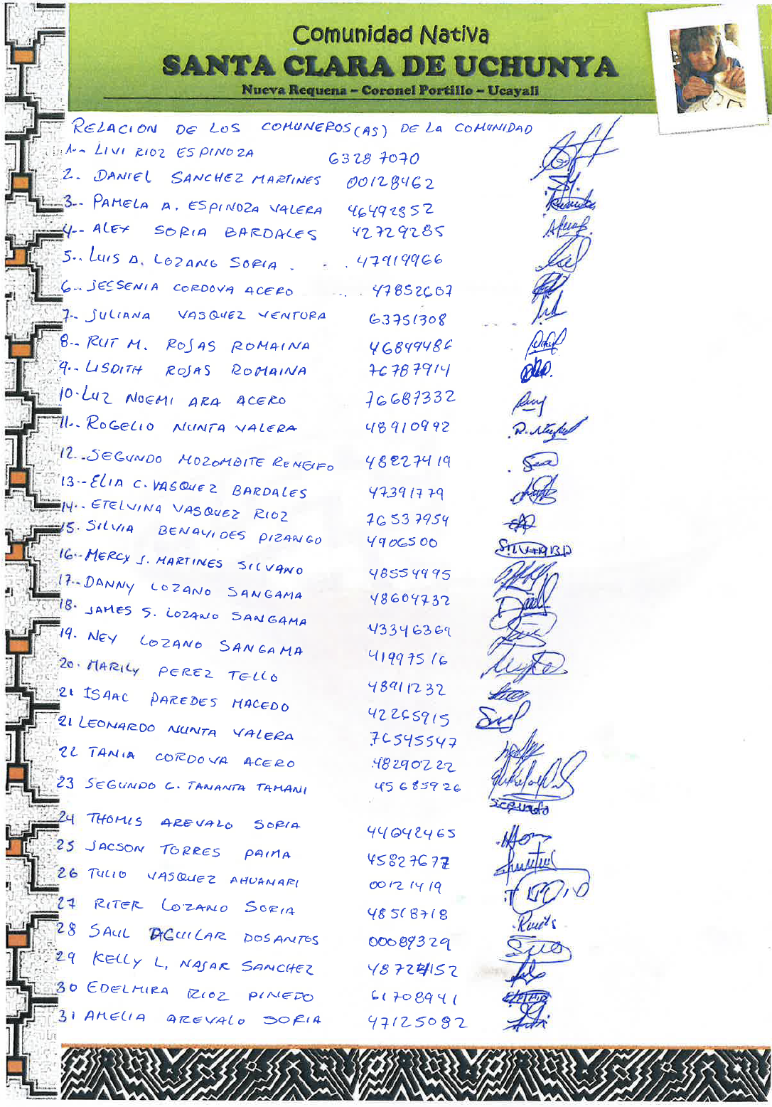
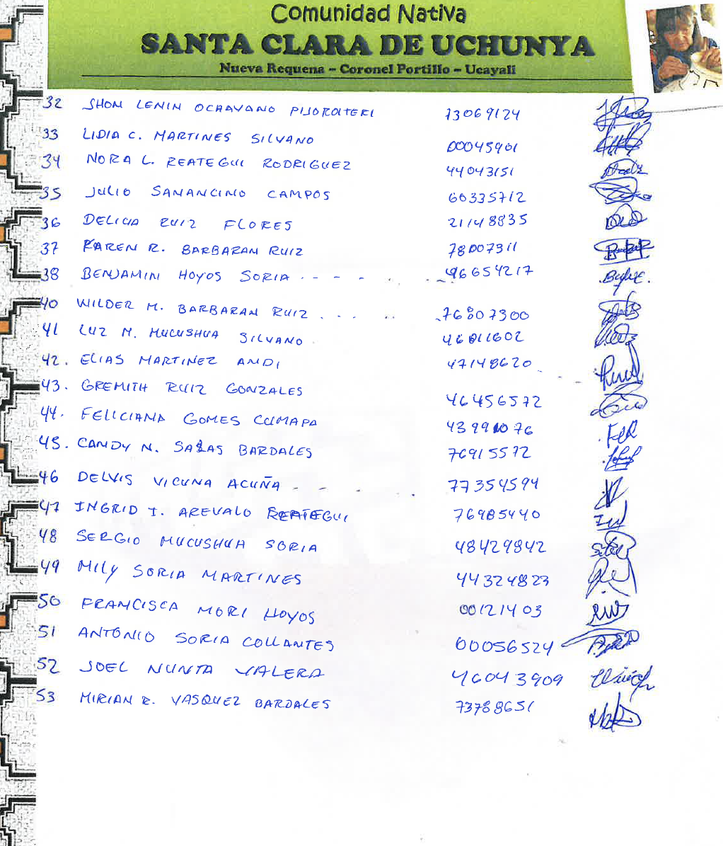

Also a letter submitted to FECONAU in the same subject.

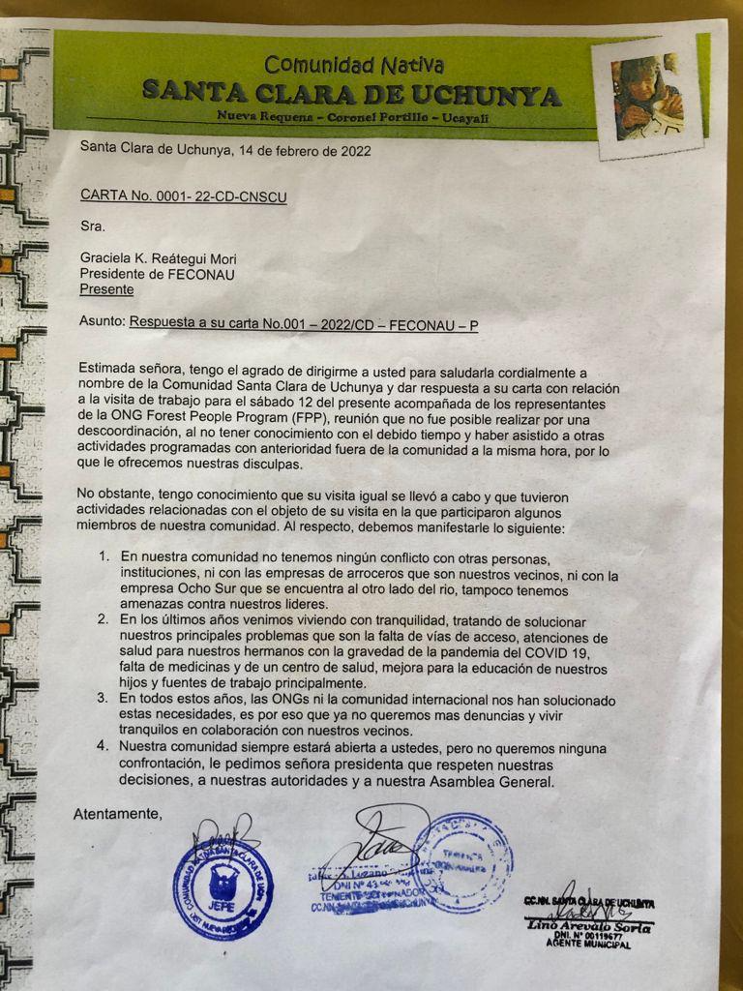
We strongly encourage you to visit the area and talk directly (without intermediaries) with the people of Santa Clara de Uchunya and their people.

Is very sad to see that certain organizations and persons don’t have any moral qualm to use humble persons and communities to seed non existing conflicts and dispute among good neighbors.

We have an excellent relation with all our neighbors including Santa Clara de Uchunya based on respect and transparency. We were proudly invited on Saturday Aug 27th to celebrate the 50th Anniversary of the Native Community Santa Clara de Uchunya. See link below.

https://www.youtube.com/watch?v=cD42OACC3V0

In addition, find below the link to a press release and a video where you can witness the true type of relation that we have with Shipibo Native Communities in the area, who named Ocho Sur as a light of hope for their people.

https://www.youtube.com/watch?v=FdkaV0FKcCc

https://www.einpresswire.com/article/569033895/the-shipibo-native-communities-are-willing-to-cooperate-with-ocho-sur

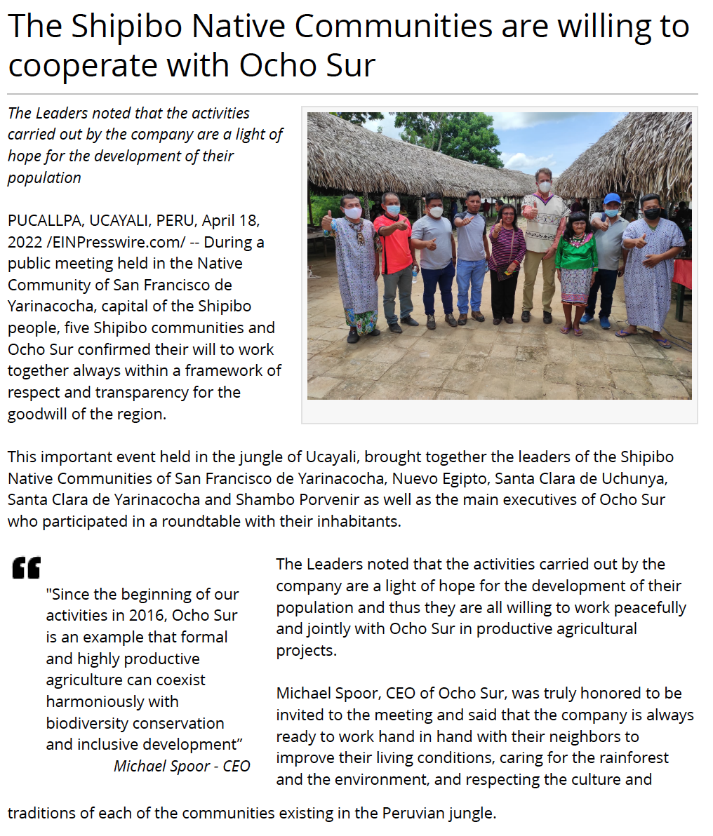
“Over five years after the community presented a lawsuit demanding the restitution, titling and remediation of their traditional lands, Peru’s Constitutional Tribunal still has not issued a decision on the community’s case. In the meantime, the palm oil company which currently operates the plantation, Ocho Sur P, has consolidated its control over the community’s territory. Hundreds of settlers have entered and continued deforesting the community’s lands, with the forest destruction covering an area three times the size of Bermuda. Peru’s environmental regulator, the Agency for Environmental Supervision and Accountability (OEFA), continues investigating Ocho Sur P for environmental damages, with hearings relating to the record multi-million dollar fines OEFA ordered the palm oil company to pay in December 2020 still ongoing”.

Misleading and outdated information.

The Constitutional Court - Peru's highest judicial body – dismissed the appeal filed in 2016 by the Institute of Legal Defense (IDL), for an alleged affectation of ancestral territories of the Native Community of Santa Clara de Uchunya (Exp. No. 03696-2017-PA/TC).

This appeal intended to annul the property deeds validly issued by authorities of the Peruvian government, for land that today forms part of the Tibecocha farm (today owned by Ocho Sur) arguing that they are ancestral territories of the community.

By this ruling, the Constitutional Court (Pleno Sentencia 22/2022) confirmed the decisions issued in the two previous judicial instances: the Combined Court of Justice of Campo Verde in 2016 and the Special Civil Court of the Superior Court of Justice of Ucayali in 2017, in first and second instance, respectively.

Regarding OEFA and the alleged “multi-million dollar fine” mentioned, it was revoked on March 30, 2021 by the same OEFA who recognized its mistake (RD No. 00672-2021-OEFA/DFAI). So that fine didn’t exist.
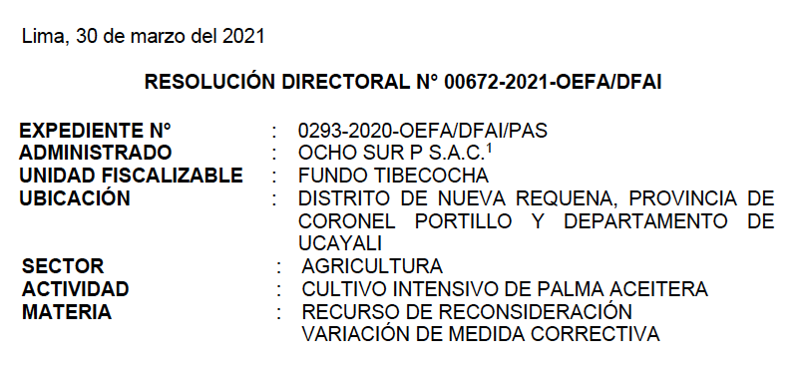
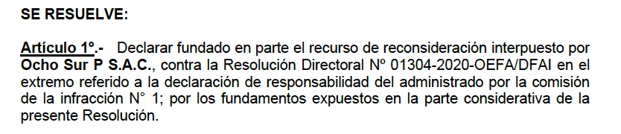

“At the same time as LDC was acquiring this palm oil associated with deforestation and Indigenous Peoples’ human rights violations in the Amazon, Santa Clara and Indigenous and human rights organisations were publicly denouncing how Ocho Sur P continued its operations even as the COVID-19 pandemic wracked urban and rural communities across Ucayali, exposing communities and workers to further risks. At present, the local criminal prosecutor’s office is investigating these allegations against Ocho Sur P. Documents subsequently obtained via information requests by Forest Peoples Programme show that neither Ocho Sur P nor Servicios Agrarios de Pucallpa had obtained the necessary permits to continue operating, despite their public claims to the contrary.”

False. Ocho Sur have never committed deforestation and never violated human rights. Again, the source of these statements are fake claims made by a few interested parties with the only objective to damage the Company´s reputation. All these fake accusations have been dismissed by the Peruvian judicial authorities because they never have any merit.

Below a link that shows some of the systematic fake claims against the company:

https://www.einpresswire.com/article/561962585/peru-s-judicial-authorities-dismissed-another-three-groundless-accusations-against-palm-company-ocho-sur

The core values of the company are based on the strict respect and care of the forest and the people. We are committed with the protection of human rights and strongly reject any action that violates human rights.

Regarding deforestation claims in Tibecocha farm, is very easy to contrast the truth. The satellite images objectively demonstrates that between 2016 and 2022, there has not been expansion of oil palm plantation in Tibecocha and contrary the forest reserved areas have increased due to the actions of the Ocho Sur.

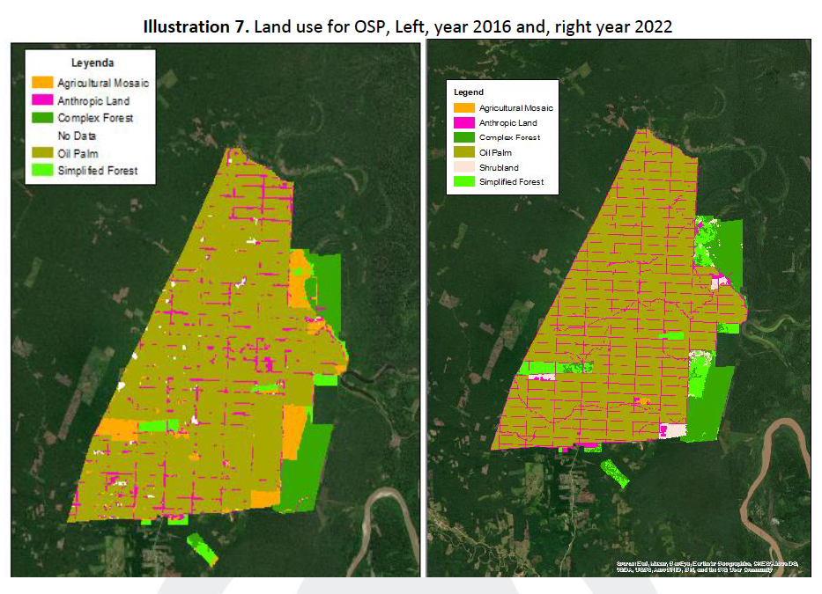

The company hired a third-party satellite image analysis by a renown international company (evaluating by SGS – Level A) in July 2022 which conclusion are the following:

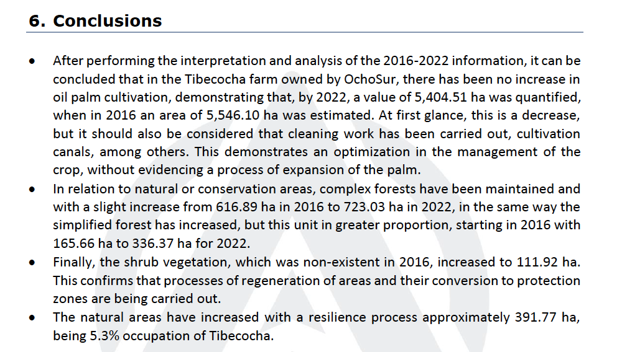
Finally, the fake claims about human rights violations and COVID19 are totally false claims and is the opposite. We are the only private Company that have worked with national health authorities to provide health assistance to neighbor communities of Nueva Requena district during the pandemic including the native communities of Santa Clara de Uchunya and Shambo Porvenir.

The company complied with all protocols and surpass all the standards stablished by the Peruvian health authorities. As a result, during COVID19 pandemic, all our workers in our camps had free access to doctors, vaccines, medical care, medicines, and oxygen. These medical care services were not available in most parts of the country. As a result, Ocho Sur was recognized by Peruvian Health care authorities for the excellent management of COVID19 with its workers and its neighbors.

See below the link:

https://www.youtube.com/watch?v=5bTQPnVAOD4&t=87s

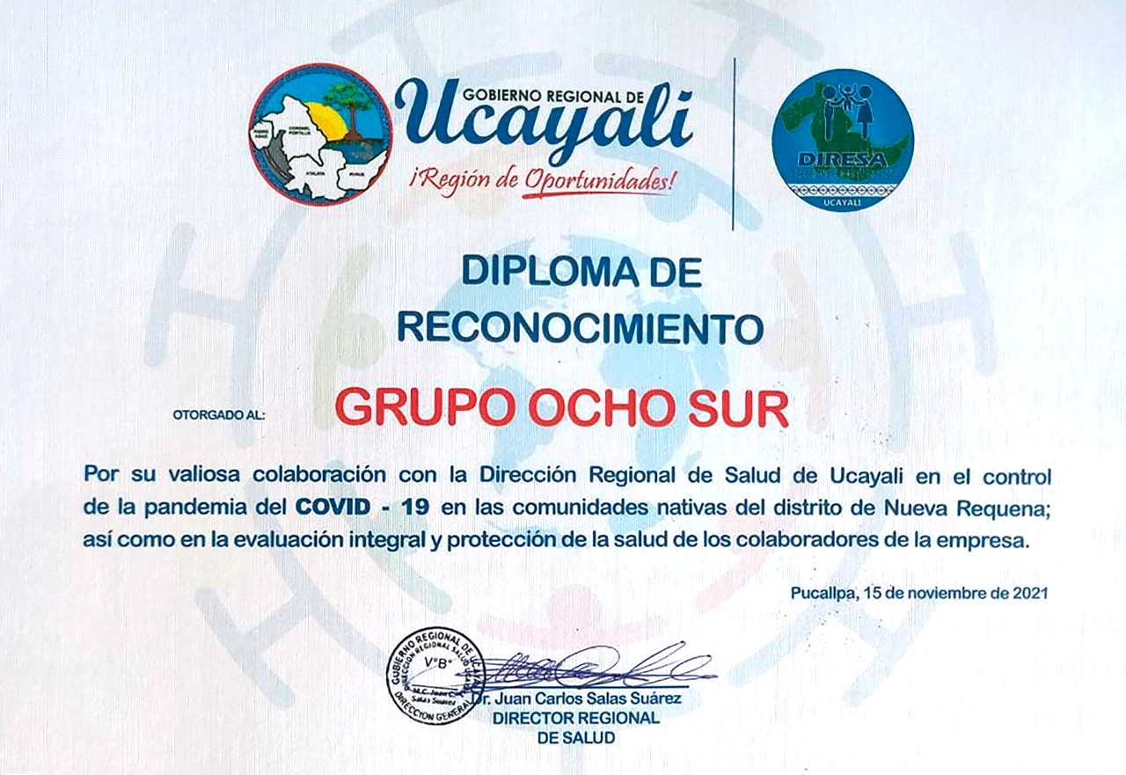

Also, below some letters from Shipibo Native communities Shambo Porvenir and Santa Clara de Uchunya recognizing the support of the Company during the Pandemic as well as government authorities.

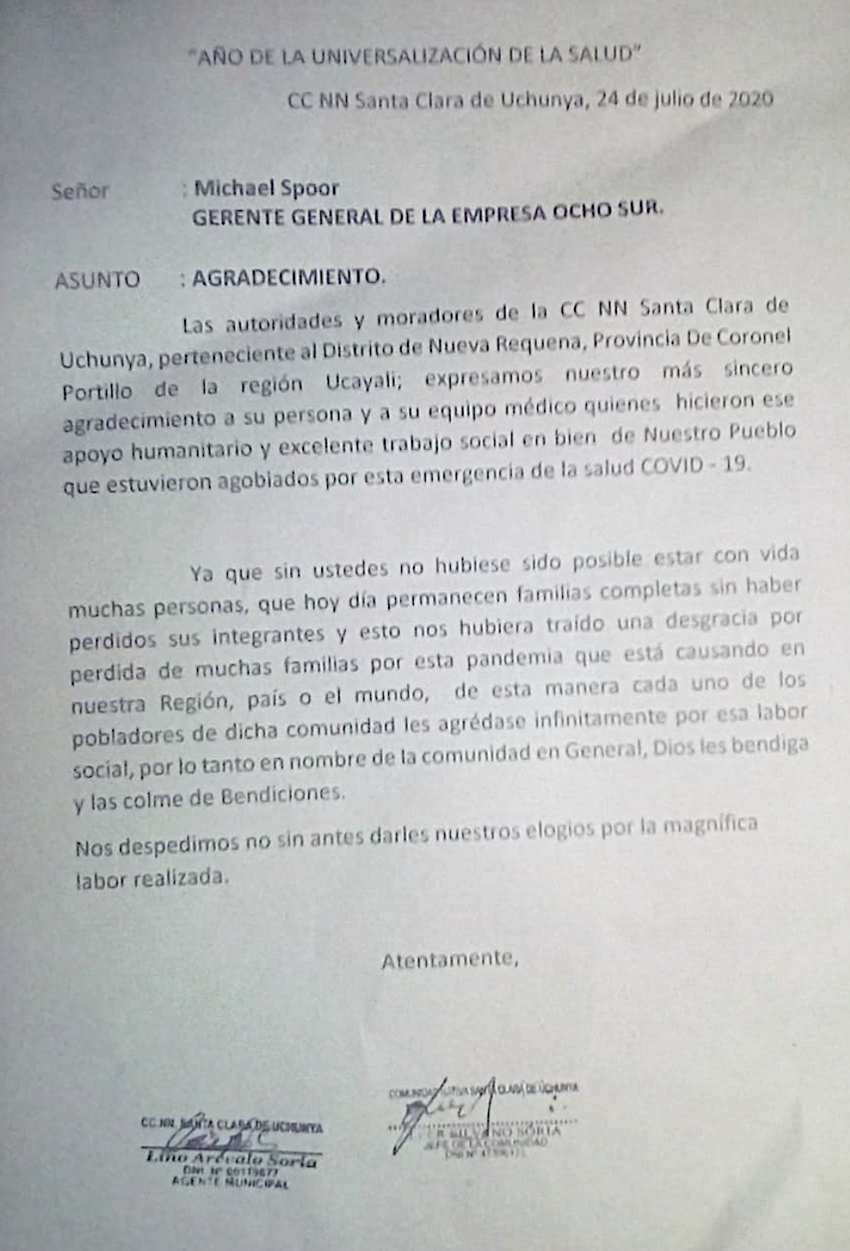
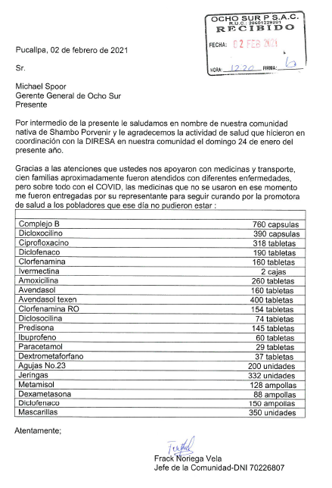

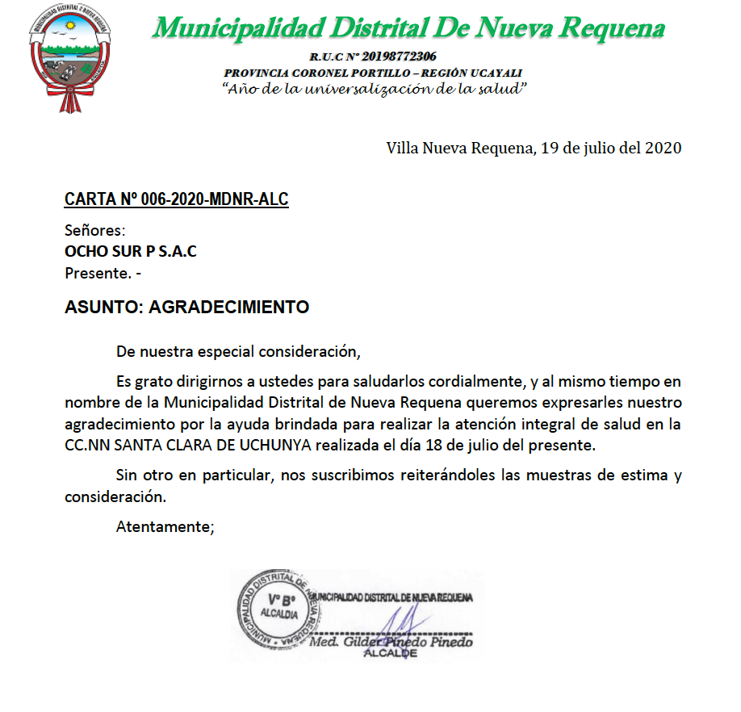

“A recent article published in Peru by Convoca drew attention to the fact that on 11 May 2021, Peruvian Palm Holdings reduced its issued share capital by 99.9%. According to Peruvian Palm Holdings’ CEO, Michael Spoor, this was due to a decision by the company and its lenders to convert part of its outstanding debt into equity to make its capital structure more sustainable as a loan matures.
However, the community’s legal advisers, the Institute of Legal Defence, have expressed concerns that this could possibly signal an attempt to transfer the ownership of Peruvian Palm Holdings’ Ucayali plantations (as happened previously in 2016 when the plantations were sold via a hastily organised auction). The plantations are currently held in a trust administered by Scotiabank Peru S.A.A. to which the Ocho Sur group and Peruvian Palm Holdings transferred their properties in August 2018. Scotiabank claims to be committed to serious social standards and the fight against climate change, however this trust may be an attempt to create an additional barrier behind which to hide the lands Santa Clara de Uchunya are fighting to have returned by Peru’s Constitutional Tribunal, leaving the deforestation and human rights violations in impunity”

Misleading and false. There is not a conspiracy theory as certain ONG raised again with the intention to damage the company’s reputation with absolutely no reason.

There has not been any capital reduction in Peruvian Palm Holdings. The contrary, in last years the shareholders have capitalized debt and increased the total equity of the company.

As we explained to CONVOCA, the change was as simple as an accounting reclassification in the Shareholder’s Equity.

The Issue capital was reduced and transferred to another equity account which is additional capital. We are being audited by one of the 4 big accounting firms in the world that can back up this simple explanation of the true facts.

There is no need to create barriers by the company because we operate in a sustainable way, with the highest ethical standards, complying with all laws and regulations, and actively promoting the well-being of the people of Ucayali. We operate in land that was legally acquired and that don’t belong to any native community.

