Forced-Labor-Produced Sea Salt Transferred Through Big Firms: This Is How Salt Arrives At Your Dinner Table.

Published: 07:30, November 18, 2023
Last edited: 09:46, November 19, 2023

[Hankyoreh S] Cover Story: “How Salt Comes to Us”

Victims of forced labor in salt farms still fighting an uphill battle to recover ordinary lives, even after escaping.
CJ(CJ CheilJedang)&Taepyeong Salt: large enterprises continuing business with formerly perpetrating salt farms… government provides facilities.
Petition to demand the US gov’t to give Withhold Release Order as the imported sea salt is “in suspicion of forced labor.”

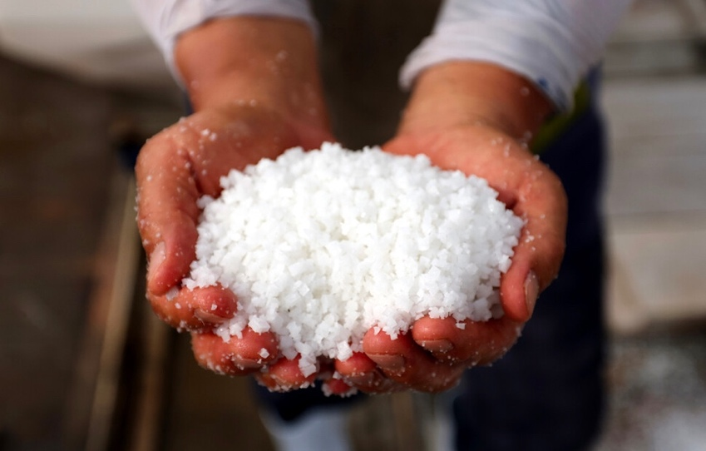
Last June, a worker holds a handful of sea salt just harvested at the salt farm, located in Shinan county, Jeollanam-do, Republic of Korea Image by reporter Jongsik Park, anaki@hani.co.kr

Salt, derived from seawater simmered down by the Sun, travels by simmering down lives that come to vulnerable in working with the seawater.

Kim Jong-Chul, a 52-year-old resident of Namyangju, Gyeonggi-do, made kimchi on the 12th of October this year. Along with his wife, he went to his in-laws' house and tossed 40 cabbages, having used in total 7 kilograms of salt. As of the 10th, the price of 5 kilograms of sea salt in Korea was 11,613 KRW (Source: Agricultural Products Distribution Information, Korea Agro-Fisheries & Food Trade Corporation, aT). The price, which averaged 7,643 KRW in 2020, rose to 8,941 KRW in 2021 and 11,146 KRW in 2022, and this year it averaged 12,669 KRW. The price of sea salt, which has been on a steady upward curve due to the decrease in the number of salt farms and climate change, rose to 13,000 KRW in June due to a shortage ahead of the discharge of contaminated water from Fukushima, Japan. Although the price has fallen from a year ago as the government released 10,000 tons of stockpiles as a measure against kimchi prices, the average price in November is still at 12,790 KRW which is 38% higher than the average price (8,427 KRW).

Even while putting salt into kimchi, Kim Jong-Chul says he was "not sure if it was safe to eat." He felt "concerned about a different kind of contamination than radioactive water." The place of production on the package of sea salt his mother-in-law had bought was Shinan County, Jeollanam-do.

Jong-Chul’s cousin, who is 47 years old and has a job in Cambridge, Massachusetts, also bought Korean sea salt at a Korean-American store on October 11th. They couldn't participate in kimjang (translated: kimjang is the term referring to the Korean traditional process of making kimchi) in a different country across the ocean, but when kimchi season came around, they would sprinkle with sea salt on at least some fresh vegetable salad.
Another cousin of his being 46-years-old lived in Frankfurt, Germany. The salt she picked up from the supermarket shelf on the 13th was also produced in Shinan county. The islands of Shinan produce 70 percent of all Korean sea salt.

The salt was salty for a reason. The seawater (1-2% of salinity) drawn into the reservoirs passed through Nanchi (the first evaporation site), Nute (the second evaporation site), and Haeju (the function warehouse) to become grains in crystalline water at the crystallin pond (20-25% of salinity). The sea salt was harvested and stored in warehouses for a long time to drain out seawater bittern. As the sea salt (about 88%) traveled the long and slow route to our dinner table, the lives that paved the way for it were also simmered down. Kim Jong-Chul doesn't want the kimchi he and his family eat to be "salted with forced labor."

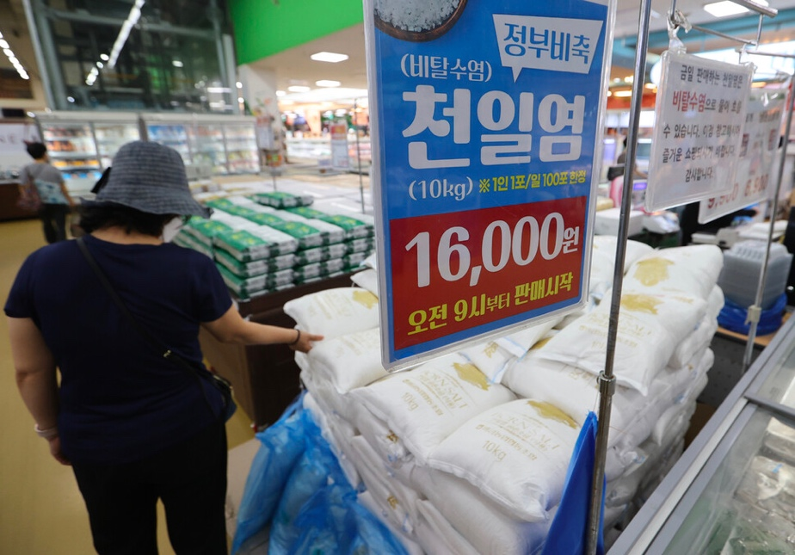
Stockpiled sea salt released by the government in response to a shortage of domestic sea salt is seen at Yangjae Hanaro Mart, a local market, in Seocho-gu, Seoul, Aug. 24, after Japan began discharging contaminated water from Fukushima, Japan. Image by YonhapNews

An escape yet to succeed

"Sir, it looks like something is broken here."

Il-guk Hong (alias/age 55/intellectual disability) pointed to a corner of the ceiling. Human rights activist Lee Ki-rim of Companion: Lawyers for Public Interests zoomed in to take a picture. The two checked the property for defects in the morning of October 27, a few days before Il-guk’s move-in at a LH(Korea Land & Housing Corportation) rental apartment complex in Daeseong-dong, Mokpo-si, Jeollanam-do. An employee at the housing management office explained the precautions to Il-guk by assuring him to "check the house carefully so that you won't be misunderstood to have made any pre-existing defects when you move out."

A bouquet of flowers was placed on the sink. Lee Ki-rim, who had picked up Il-guk half an hour earlier at the temporary housing, gave him the bouquet as soon as she saw him.

"Today is a good day, congratulations."

It was a hard-fought move. The previous temporary housing was the home of the parents of a counselor at Ki-rim's former employer, the Advocacy Agency for Persons with Disabilities, where victims of salt farm abuse, like Il-guk, who had nowhere else to go stayed on an "emergency basis" until they could find housing.

Il-guk escaped in May 2021 from a salt farm in Shinan, the starting point for "sea salt that goes beyond Korea to the world." He was the first person to expose the ongoing status of the same salt farm labor crisis that had shocked Korea in 2014. He worked for 17 hours a day, but his employer didn't pay him. Wages were calculated as annual salary instead of monthly salary, and the money that was deposited into Il-guk’s bank account in the form of a monthly salary was taken back by making him go to the bank to retrieve it. The employer exploited the workers' intellectual disabilities (the investigating agency calculated that Il-guk's unpaid wages amounted to more than 115 million KRW) and virtually imprisoned them, as Il-guk claimed. His revelations led to police investigations and administrative investigations (27 out of 69 respondents, 39.1 percent, were people with disabilities or suspected of being with disabilities, according to the 2022 'Jeollanam-do Salt Farm Workers' Working Conditions Survey Study').

"He is a victim of salt farm abuse."

After signing the lease, Ki-rim went with Il-guk to the local administrative welfare center to help him register for a new apartment. She also asked for support from welfare services.
"He came to this neighborhood because he was selected as the beneficiary for the social ladder project for the socially disadvantaged. He can't cook for himself, so he needs help with side dishes."

When they left the administrative center, Il-guk asked Ki-rim.

"Will the rice (given while living in the other neighborhood) come with me?"
"Don't worry. When you change your address, the rice will be transferred."

Taepyeong Salt Farm in Jeungdo, Shinan County is the salt field that Mr. Il-guk escaped from. It is recorded as the largest salt farm in Korea (designated as National Registered Cultural Property No. 360 in 2007), and Il-guk's employer was one of its tenants (having leased the land in exchange for 50 percent of the production). After Il-guk's revelations were reported, there was a "coordination of stories" and hiding of victims. When another worker with intellectual disabilities, Chang-beom Choi (alias/49/over 8,800 million won in unpaid wages), was summoned by the police as a witness, his employer instructed him to "keep his mouth shut and not answer any questions." The indictment also included forcing him to state that he had received wages every month.

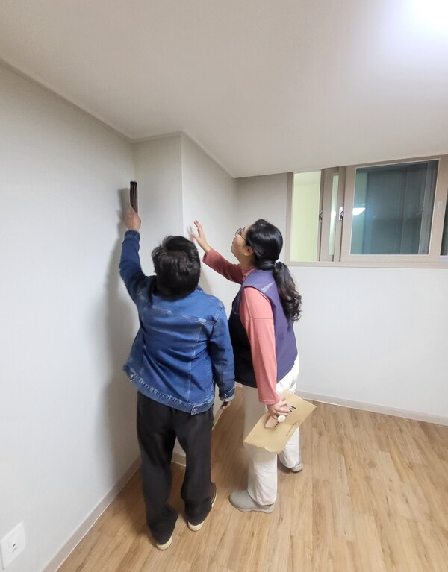
Il-guk Hong(alias), a victim of forced labor in salt farms, checks the defects of the house he will move into in a few days with Lawyer Ki-rim Lee (Companion: Lawyers for Public Interests) at LH-purchased rental housing in Daeseong-dong, Mokpo-si, Jeollanam-do, on the morning of Oct. 27. Image by reporter Moon-young Lee

At the time of the incident, Ki-rim was a member of the Advocacy Agency for Persons with Disabilities (a statutory organization established in the wake of the 2014 salt farm human rights violation incident) and visited the site to meet with the victims. The perpetrating employer took Chang-beom and other victims away from the salt farms to a motel ahead of further investigations planned by Ki-rim. The father and son, who were the employers of Il-guk and Chang-beom, were punished in 2014 for quasi-fraud, confinement, and violations of the Labor Standards Act against persons with disabilities. The father (sentenced to 10 months in prison and two years' probation) failed to pay an orphaned victim with disabilities eight years' worth of wages. The son (sentenced to 2 years and 6 months in prison) took the victim to his own pub and forced them to work there without pay. Fearing that the exploitation would be discovered when the incident was published, he hid them in a motel in Mokpo and had someone watch over to make sure they didn't go outside. The son also ran a brothel in Mokpo.

The fact that the perpetrator of the exploitation continued to successfully run the sea salt business for seven more years after being punished is a reality of the salt industry that is untrackable by the sea salt traceability system (which is a certificate system intended to function as a device to reduce non-transparency in production and distribution, but whose effectiveness is controversial because of lacking obligation). In the meantime, punishment has been lukewarm, and legislation (the Act on Prevention of Human Trafficking and Protection of Victims, enacted in January of this year, has faced criticism for its lack of punitive provisions) has been perfunctory.

"Securing a safe life is the key to ending abuse"

"You have a nice house. Let's trade places."

Jinman Jeong(alias/age 60/borderline intellectual disabilities) jokingly said to Il-guk as he cut cold noodles with scissors. After picking out a used refrigerator, television, stove, and chest of drawers at a recycling center for Il-guk’s new home, the group had a late lunch at a restaurant. “Don’t be ridiculous,” Il-guk said, and cut his cold noodles into small pieces.

Ever since Ki-rim met Il-guk that morning, Jinman had been with him. Jinman, who had begun staying in a temporary shelter before Il-guk, had now moved into a permanent apartment. Jinman felt jealous of Il-guk, who was living in a new building. His old apartment building, 30 years old, didn't have an elevator. He suffered from spinal stenosis due to an untreated back injury from his salt farm job, and had to endure recurring pain every time he climbed the stairs.

Jinman also worked in the same salt farm as Il-guk. During his 10 years of work, his annual salary ranged from minus 2,000,000 KRW or 100,000 KRW if he added the "boss's special bonus," to 150,000 KRW at most. This is due to the fact that suspense payments in the document falsified by the employer are higher than his salary. He had put his thumbprint on the document that states he “personally checked” the “salary settlement confirmation” with the amount and that he “will be held civilly and criminally liable if there is a problem with the confirmation in the future.” Employers got credit cards in the names of workers with disabilities to actually use them for personal purposes, take out loans, or collect welfare payments from the labor incentive program run by the government. They collected insurance payments on behalf of workers injured in car accidents. When unpaid victims asked their families to send money in desperation, the money was moved by the employers to their wives' accounts and used to fund gambling.

Il-guk and Jinman chewed on the chopped cold noodles for quite a while. Il-guk had no teeth left in his mouth, and none of Jinman's remaining teeth were in good condition. "When their teeth were damaged by hard labor, their employer called an unauthorized dental technician to grind their raw teeth and paid them 5 million won each from workers’ salaries(according to Ki-rim)”.

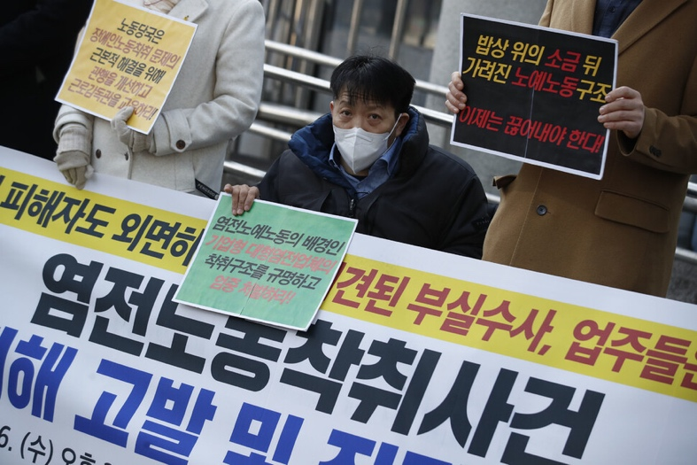
Participants in a press conference to publicize the recurring labor exploitation incident in salt farms, held in front of the Seodaemun-gu Police Station in Seoul, South Korea, on Jan. 26, 2018, call for an active police investigation and strict punishment. Photo by Kim Hye-yoon unique@hani.co.kr

After lunch, they went to borrow some tools from Chang-beom to clean Il-guk's apartment. Chang-beom's rental house was in a different neighborhood from Il-guk’s, but the design was exactly the same.

"Uncle Chang-beom, are you coming to help Uncle Il-guk move on Sunday?"

Ki-rim asked as she packed the cleaning tools, and Chang-beom shook his head bluntly. He was one of the workers whose employer had taken to a motel to prevent them from meeting with Ki-rim. After breaking off the meeting, the employer called Chang-beom who he had sent back to his parents' house in Seoul. He called Chang-beom's father, had him drive Chang-beom down to Mokpo to prevent him from going elsewhere, and gave him 1 million KRW.

Most of the salt farm workers had no home to return to. They were either cut off from their families or their families handed them over to the salt farms themselves. Even if they wanted to leave, many gave up because they had nowhere else to go but the salt farms. Il-guk's disclosure led to his employer's arrest and detention in late November 2021. A month after his detention, Chang-beom took advantage of slackening surveillance by his employer's family to call Ki-rim and ask for help.

Chang-beom was also a victim of the same salt farm human rights violation incident back in 2014. After being assaulted by the salt farm owner, he was sent to another island when an investigation began. After leaving, he had nowhere to go and had to stay in homeless facilities and psychiatric hospitals. "The experience fostered a sense of helplessness that nothing would change even if he left(according to Ki-rim).”

Even after he was rescued from the salt farm seven years later, there was still no public space for him to live in. At the time of his rescue, the shelter for abuse victims in Jeollanam-do had stopped operating. Ki-rim searched for "Chang-beom’s place" in a home for people with disabilities, but no stable housing or self-support services were provided. "There is a certain amount of funding set aside for independent settlement for people with disabilities who have been deinstitutionalized, victims of sex trafficking, and people who have been released from child protection facilities, but there is none for people with disabilities who have been abused” (according to Ki-rim). The victims had no choice but to wander the streets for hostels or motels. Meanwhile, Chang-beom was reintroduced to a salt farm (in January last year). He was being transferred to the salt fields through a private job agency, but just before entering, he asked Ki-rim for help again. Ki-rim called the police and rescued him by tracking his location.

Il-guk's life "after rescue” was no different. Struggling with programs at a shelter for persons with disabilities that didn't suit him, he eventually found his way to the seaside, moving from one fishing boat to another harvesting shrimp, crab, or butterfish, returning to a job similar to salt farm labor. When he came to Mokpo for a trial, Ki-rim convinced him to stay in the area.

The victims' failure to recover their daily lives was also a reason for the recurrence of forced labor in the salt farms. In 2014, 20 (31.7%) of the 63 victims identified in Sinuido, Shinan county, returned to the salt farms(Report on the In-depth Survey of Persons with Disabilities in Salt farms by the Research Institute of Differently Disabled People Rights). 16 of them (25.4%) spent time in homeless facilities, and only eight (12.7%) returned home. Ki-rim filled the gaps in the public support system with personal time and resources. As an unofficial public guardian, she worked closely with them to secure housing, register for disability and benefits, get medical care, support activities, connect them to vocational training and independent work, and even trial assistance. "We needed to see at least one case of meaningful reintegration of the rescued victims into society in order to get them out of the salt farms," she said. "Ensuring the safe lives of victims with disabilities is the fastest way to end abuse."

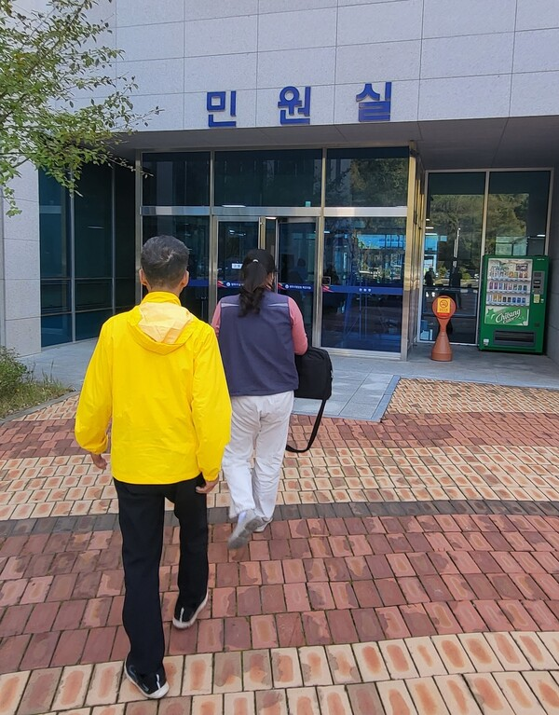
Jeong Jinman (pseudonym), a victim of forced labor in the salt farms, enters the Mokpo Branch of Gwangju District Court with activist Lee Ki-rim, a "person with reliable relationship," to testify in the trial on Oct. 27. Photo by Moon Young Lee

The trial still in process for nearly two years...

"Once (the defendants) are inside, we will proceed with the witness examination non-face-to-face."

In accordance with the judge's policy, a court security officer escorted the defendants to a side room in the courtroom. The door was left slightly ajar so they could be heard.

At 4 p.m., Jinman walked into the criminal courtroom of Mokpo Branch of Gwangju District Court. After waiting in the witness support room, he entered the courtroom from the back with Ki-rim. After being sworn in, Jinman took the witness stand, while Ki-rim sat next to him as a person with reliable relationship.

The first trial against the employer (charged for fraud, embezzlement, violation of the Telecommunications Business Act, etc.), which began in January last year, continued for more than two years without an end. From May last year to this May, three more indictments (violation of the Labor Standards Act and the Disability Welfare Act, and quasi-fraud) were added, making a total of four cases. The number of defendants expanded to include the entire family of the employer's father, mother, and wife, and the prosecutors and judges were changed several times.

"Did the family members of defendants come out?"

Jinman asked Ki-rim when they arrived at the courthouse parking lot. He was afraid of meeting them. Ki-rim applied to the court for "witness support" (a system that helps witnesses in criminal cases testify safely) and accompanied the victims to court, to the deposition, and home afterward, making sure their paths didn't cross with the defendants.

Jinman was saved by Chang-beom's statement to the police. When he told the police about his employer's mistreatment, he revealed that Jinman ("his back hurts so much that he would fall consistently, but my employer doesn't take him to the hospital") and another coworker with disabilities(“They were in charge of cooking meals and the employer kept beating them because the food was too salty or bland.") were also victims. Jinman, who was removed from the island in February of last year due to Chang-beom's statement and investigated by the Jeollanam-do Police Agency (located in Muan county), refused to return to the salt farm after the investigation. He has borderline intellectual disabilities and was excluded from disability support because he was not registered as a person with disabilities. His stay at a shelter for victims of violent crimes was also limited in time.

"Did you ever receive instructions from Mr.O (the employer's father) not to go out of the salt farms (after the employer's detention)?"

The defense attorney asked.

"He told me that if I was caught running away, he would kill me."

"You said you didn't hear that during the police investigation, but did you actually hear that?"

"Yes."

The defense attorney pressed Jinman.

"Then what you said to the police is not true. Is there a reason why you said you didn't hear that in the police investigation, but you are saying otherwise in court? Did (someone) threaten you to say that?"

When asked by the police if his employer's family had ever prevented him from leaving the salt farms or monitored him to make sure he didn't, Mr. Jinman said no. After being rescued, he recanted his statement, saying that he was "scared and couldn't speak properly. While his statements to the police were made at the defendants' direction, the defense attorney asked in court whether the change in his testimony was due to pressure from activists. The defendants refused to admit that the victims were people with disabilities and denied assault, coercion, and intimidation.

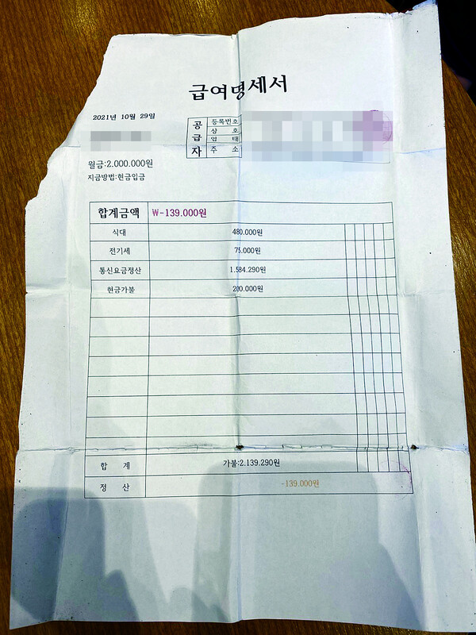
A paycheck stub held by Jinman Jeong(alias) on the day of his escape from the Shinan salt farms in Jeollanam-do last February. False deductions made by his employer were larger than his salary, resulting in a “negative total amount.” Photo provided by Jeong Jin-man

The defendants’ family leased more than 10 slots (sea salt production floors) at the Taepyeong Salt Farm to harvest salt. Instead of the actual employer, the family rented in the names of their wife, sister, sister-in-law, brother-in-law, etc. In November 2021, Shinan county imposed a one-year business suspension on only three plates leased in the name of the wife, citing the lack of a leased salt farm in the employer's name. Taepyeong Salt Company stated that it had "terminated the contracts of all 10 plates" (said during trial on November 22, 2022), but the defendants continued to produce salt at the remaining plates for the past year through suits on real estate occupation transfer.

Jinman worked as a self-supporting worker at the fish trap manufacturing factory. To get to the factory, Jinman had to pass by "that coffee shop.” The coffee shop, near Mokpo Station, was located in a cluster of private job agencies on a street victims and activists call "a trafficking alley.” The alley is filled with Karaoke and dance halls, internet cafés, massage parlors, and bars. The coffee shop in question served as a job agency and a motel simultaneously. Forced labor in the salt farms was also proliferated through the medium of job agencies. Job agencies would lure people with intellectual disabilities into debt with accommodation, entertainment, and sometimes even prostitution, and the salt farm owners would pay the debt in the form of an "advance payment" to take them away.

Jinman, who was introduced to the defendants’ sea salt business through "that coffee shop," was also sent to employer J's salt farm in 2014, for which the employer was punished (6 months in prison and 2 years of probation for quasi-fraud). Before coming to the accused family's salt farm, Jinman worked at employer J's salt field for five years.

The employer J was also a tenant of Taepyeong Salt Farm. After hiring him to work with the promise of "1 million won per month," he failed to pay him 25.88 million won from October 2011 to December 2013. The court recognized his intent, saying, "He paid wages to other employees but not to the victim." The employer J still maintains a contract with the Taepyeong Salt to produce salt.

This is how the 'contaminated salt' has ended up on our dinner tables. Salt from salt farms that exploited workers with disabilities was a key ingredient for kimchi made this year, largely due to problems in the supply chain.

Salt with the 'exploitation history' came to our table
Kim Jong-Chul is a lawyer at APIL: Advocates for Public Interest Law. His organization, APIL, has been providing efforts to stop forced labor in Korea's salt farms. Since August last year, the organization has sent numerous letters of inquiry to large salt companies including Taepyeong Salt, CJ CheilJedang, and Daesang. The inquiry was based on the belief that the salt-producing and processing companies are not fulfilling their own responsibilities to eliminate forced labor in their supply chains. APIL asked whether the companies are aware of the human rights conditions of the salt farms they currently are in contract with, and whether any of those farms have a history of exploitation of people with disabilities.

Taepyeong Salt, which had outsourced production to the perpetrators of Il-guk, Changbeom, and Jinman, responded, "We cannot interfere with management because hiring workers is the inherent right of the tenants." A company official told Hankyoreh, "We have a policy of not signing the next contract if human rights violations are reported and confirmed," but when asked why the company maintained the contract with employer J, they said, "It is difficult to supervise their personal lives, and we know that the past issues have been already resolved."
Daesang Corporation responded to APIL by saying, "To select suppliers, we evaluate and manage items such as human rights, workplace environment, and quality of salt every April."

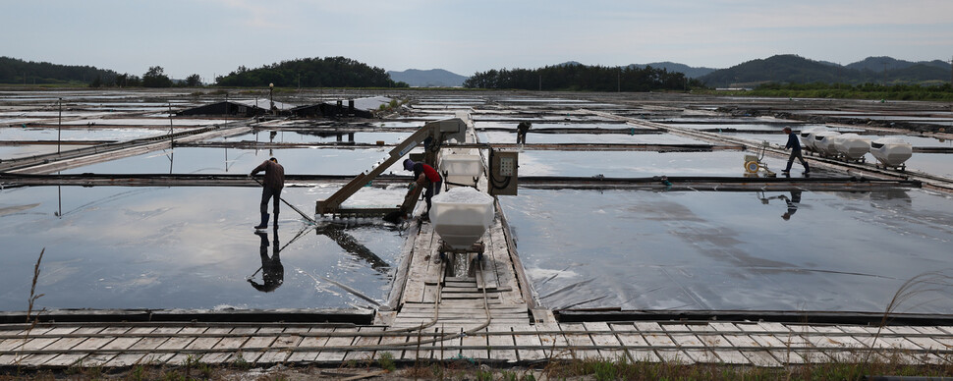
Workers collect salt grains with a simoussi(a tool for harvesting salt) at a salt farm in Shinan county, Jeollanam-do, last June, when there was a shortage of sea salt in Korea ahead of the release of contaminated water from Fukushima, Japan. Photo by reporter Park Jong-sik anaki@hani.co.kr

CJ CheilJedang "conducted its first human rights impact assessment on its subsidiaries in 2021," but excluded its sea salt operations from the assessment that year (the company confirmed in reply on August 24, 2022). The first human rights due diligence at the salt fields was "conducted for one day on September 29," a month after the response (said to Hankyoreh). "The due diligence showed that there were no special human rights violations," it said.

In 2014, there were media reports that the shareholders of CJ CheilJedang's subsidiary (Sinuido Sea Salt) included four perpetrators of forced labor. CJ CheilJedang stated to APIL that "law enforcement has been completed for three of the four" and that "these three are currently shareholders of Sinuido Sea Salt." The company also said it had "suspended purchase contracts with the four perpetrators," but confirmed facts differed from the truth.

Independent/non-affiliated lawmaker Mi-hyang Yoon received the details of sea salt supplied to CJ CheilJedang from the Ministry of Oceans and Fisheries (※ marks data obtained from Yoon's office). From July 2022 to June 2023, 4.97 million kilograms were received from more than 30 salt farms. Among the salt farms there was the salt farm owned by employer B, which supplied 180,000 kilograms.

Employer B was one of the perpetrators in the 2014 human rights violation incident in the salt farms. In October 2008, B recruited a person with intellectual disabilities through a job agency in Mokpo, lying to him that he would get paid 4 million KRW a year. B put him to work at his salt farm and shrimp farm in Sinuido and did not pay him until January 2014. "From the time (employer B) brought the victim to work, it was his intention to make him work without paying him wages," the court found. He also assaulted two other workers for putting seawater into the wrong salt farms and not putting salt into the pails quickly enough. He was arrested in April 2014 and sentenced in July that year to one year in prison and three years' probation (decision by Mokpo Branch of Gwangju District Court) for quasi-fraud and violation of the Labor Standards Act.

Employer B was a producer representative when CJ CheilJedang established 'Sinuido Sea Salt' in 2010 as a cooperative with Sinuido salt farm owners. In 2014, he was a member of the Shinan County Legislature and is still a county legislator (for 3 terms total). From 2014, when he was criminally punished, to last September, he delivered a total of 885,800 kilograms (※) of salt to CJ CheilJedang.

"According to law, just because a shareholder has been criminally punished, other shareholders cannot collectively take away that shareholder's shares," a CJ CheilJedang company official told Hankyoreh. "It is true that the shareholder is still supplying salt, but the issue has already been legally resolved," he added. However a labor inspection conducted by the Ministry of Employment and Labor in July last year (※) also found B’s violations of the Labor Standards Act and the Minimum Wage Act.

Taxpayer money was also used to fund the perpetrators’ salt farms. According to the Salt Industry Promotion Act, the Ministry of Oceans and Fisheries has provided annual support to salt farms to produce and distribute sea salt. From 2013 to last year, employer B received 122 million won in support for improving sea salt flooring and automating salt extraction (※ Jeollanam-do 'State Support by Salt Field'). Employer J also received 124.3 million won from 2014 to last year. Yoon said, "The law stipulates that 'the Minister of Oceans and Fisheries may request to have the funds provided returned if it is found that a worker is forced to work against his or her free will' (Article 49.2), but until we requested the data, it was not even sorted out how much government support was provided to each salt farm." She emphasized that "responsible management and supervision by the government is urgently needed."

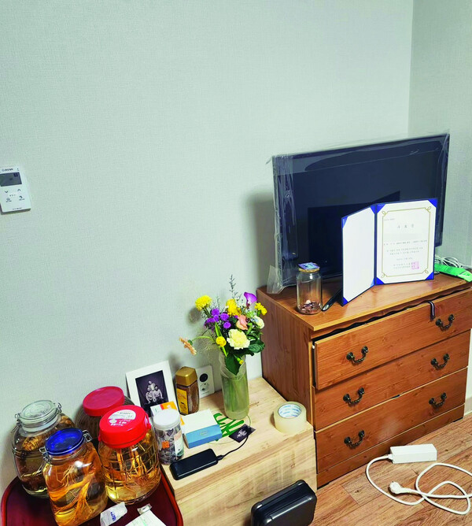
In this photo of Il-guk(alias)’s new home, a congratulatory bouquet of flowers from an activist and homemade mountain herb wine made for his housewarming sits in the room where he moved in on Oct. 29. Photo by Ki-rim Lee

On the 16th of last month, APIL sent the fourth letter of inquiry to CJ CheilJedang. They asked again about the Oct. 4 response from last year, which stated that "out of the 43 salt farms (that supply salt for Sinuido Sea Salt), only eight employ workers, and none of them employ people with intellectual disabilities."

"Please clarify what means are used to determine whether a worker has intellectual disabilities,” requested APIL.

"With the exception of professionals from the Advocacy Agency for Persons with Disabilities" who respond to and investigate reports of abuse, "virtually no one was able to use assessment indicators to determine whether a person had disabilities in the salt farms(according to Ki-rim). Depending on how the questions were asked, the results can vary greatly.

APIL also asked CJ Foods USA based in California, and CJ EUROPE GMBH based in Frankfurt, Germany, whether the salt they import and produce is sourced from forced labor. California and Germany have laws requiring companies to disclose measures to address forced labor in their supply chains and to conduct human rights due diligence.

In November of last year, APIL, The Research Institute of the Differently Abled People Rights, and Wongok Law Firm petitioned the U.S. Customs and Border Protection for a Withhold Release Order against South Korean sea salt suspected of forced labor. The petition seeks to halt distribution of the products in the U.S. until the companies eliminate forced labor from their supply chains, as victims have been re-victimized or sea salt continues to be produced in businesses that were previously prosecuted for exploiting people with disabilities.

Products subject to the order must be proven to be free of forced labor before they can be released into the U.S. market. Currently, exports from 35 Chinese companies (not counting Xinjiang Uyghur related cases) are being held at the U.S. Customs. One Japanese company's products are being held, and none from South Korea.

By Lee Moon-young, Reporter moon0@hani.co.kr
Original Text: https://www.hani.co.kr/arti/society/rights/1116826.html
Translation by Lee Soun from Advocates for Public Interest Law

