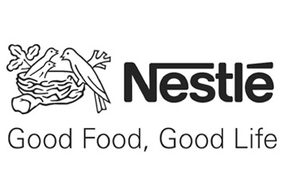

Nestlé faces lawsuit in US federal court alleging use of fish sourced from Thai company using slave labour, Business & Human Rights Resource Center Weekly Update, 2 September 2015

Nestlé response:

Forced labour has no place in our supply chain. Our mandatory Nestlé Supplier Code and Responsible Sourcing Guideline (RSG) on Fish and Seafood require all of our suppliers to respect human rights and to comply with all applicable labour laws.

The elimination of forced labour in our seafood supply chain is a shared responsibility and we are committed to working with global and local stakeholders to tackle this serious and complex issue.

Southeast Asia’s supply chain issues call for proactive and concerted efforts to identify and eradicate instances of forced labour that cannot be properly addressed through lawsuits such as the one recently filed in the US.

Over the past 12 months, we have been working with the independent supply chain consultancy Achilles to better understand the multi layered supply chain in the Thai seafood industry which supplies some ingredients for our products.

Building on this, our NGO partner Verité, has collected information from fishing vessels, ports, mills and farms in Thailand to identify where and why forced labour and human rights abuses may be taking place. We will publish Verité’s key findings alongside a time-bound action plan to address the issues identified in the fourth quarter of 2015.

Nestlé is also proactively engaging suppliers and other organisations in the Thai seafood trade to share learnings to date and to agree what actions should be taken.

In addition, Nestlé is participating in a multi-stakeholder International Labour Organisation (ILO) Working Group, consisting of representatives from the Government of Thailand, local seafood suppliers, and international buyers. This group has developed training guidelines for factories, primary processors and fish farms to help end unfair practices, and tools to support the inspection of fishing vessels to identify where forced and child labour is taking place.

