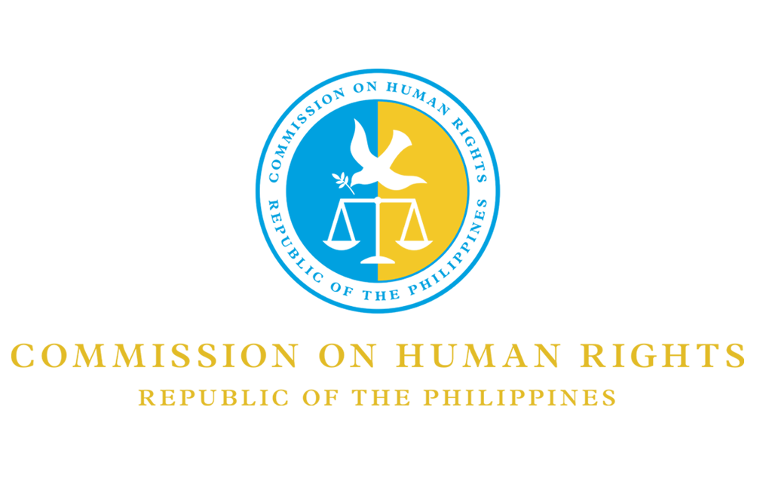

National Inquiry on the Impact of Climate Change
on the Human Rights of the Filipino People

12 December 2017
PRESS RELEASE

CHR holds conference with the parties

QUEZON CITY—The Commission on Human Rights (CHR) called on the petitioners and respondents for a conference on Monday, December 11, for its ongoing landmark national inquiry meant to examine the possible contribution of carbon majors on climate change and its effects on the human rights of the Filipinos.

“The inquiry hopes to shed light on the petition filed before the Commission on the alleged responsibility of companies using fossil fuel, also known as ‘carbon majors’ on the reported effects of climate change on the Filipino people,” said CHR Commissioner Roberto Eugenio Cadiz, who chairs the said national inquiry.

The petition, supported mostly by farmers, human rights groups, and concerned citizens, was filed after a spate of natural disasters such as Super Typhoon Yolanda, internationally known as Typhoon Haiyan, visited the Philippines.

National inquiry

The conference officially set the groundwork for the first formal inquiry hearing to be conducted at the end of the first quarter of next year, 2018.

“The Commission accepted the petition, in accordance with our general mandate to uphold the human rights of all Filipinos and, towards this end, to investigate and monitor all matters concerning the human rights of the Filipino people,” Commissioner Cadiz explained.

CHR is also mandated to monitor compliance by the government with its domestic and international human rights obligations, such as those involving treaties, conventions, and customary international law, including the Paris Agreement, the Kyoto Protocol, the International Covenant on Civil and Political Rights, and the International Covenant on Economic, Social, and Cultural Rights.

Prior to the parties’ conference, the Commission has already conducted fact-finding missions in Tacloban City, Leyte and Libon, Albay. The Commission shall conduct more of these fact-finding missions and community dialogues until the first half of 2018.

“The inquiry, it is hoped, would result in the improvement and development of measures to further uphold and respect human rights” Cadiz noted. ■

Contact Person:
Ms. Julian Inah G. Anunciacion
Project Coordinator, National Inquiry on Climate Change
Commission on Human Rights
Telephone no.: (02) 925 3883

