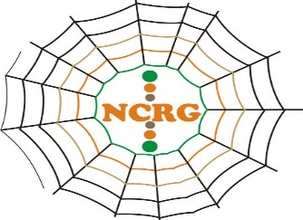
NETWORK FOR COMMUNITY RESOURCE GOVERNANCE
Room 302, Security House. Opposite Barclays Bank,
Buteko Avenue- Ndola, Zambia.
Contact: +260 967 701213 /+260 974 470 585 Email: ncrgsecretariat@gmail.com
………………………………………………….................................................................................................................................................

Clive Newall
President
First Quantum Minerals
July 30th 2018
RE: COMMUNITY GRIEVANCE AGAINST FQM
We write to bring to your attention how First Quantum Minerals’ resettlement program in Zambia’s 21 Miles Village has negatively impacted the local community and seek your intervention in the matter.
By way of introduction, the Network for Community Resource Governance (NCRG) is a youth-led network of Mining communities in Zambia that empowers communities to demand their rights and benefits from the minerals. NCRG wants to build on a continuous basis communities that can represent themselves. NCRG is constituted of experts who live within the affected communities.
As you may be aware, there is a copper mine initially operated by FQM located 2 km from the Zambian border, near Sakania, and currently operated by Eurasian Resources Group (ERG). Though located in the Democratic Republic of Congo, the mine has direct negative social challenges to the Zambian community of 21 miles including on the local community relocated by FQM to pave way for your company’s entrance to the mine.
Our investigations reveal that the community first settled in this area in 1971, under Philemon Chitushi’s leadership, who was originally from North-Western province after he discovered fertile farming land. This community has since settled in the area with subsistence farming as their main livelihood. It has grown to approximately 882 households.
According to Margret Chitushi who is the current village leader, FQM approached the Community and made its intentions to relocate them. Meetings were held with the community and various environmental assessments were undertaken. In 2009 the community was relocated and settled in a nearby area, currently owned by FQM. The villagers have several grievances regarding the resettlement.
- The houses that they were allocated are one bedroomed regardless of the size of the family. For instance, Beatrice Kashita, one of the relocated residents complains that the house she was relocated to is too small for her family of 12 people. This has forced her to construct additional grass-thatched houses to accommodate all the members of her household.
- The houses lack proper ventilation and some have incomplete flooring.
- FQM has not fulfilled its pledge to construct social amenities such as school and health facilities. Their children have to travel long distances to access the nearby public school with some opting to discontinue schooling.
- The land on which FQM resettled the villagers is less fertile than where they had originally settled. This has led to a drastic decline in food production compromising the villagers’ ability to meet their food requirement and sell any surplus to the market to meet their basic needs, as they used to in the past.
- FQM did not fulfil its undertaking to provide them with basic food supplies for one year immediately after the relocation.
- FQM did not fulfil its undertaking to provide them with farm inputs for five years immediately after the relocation to support them with adaptation techniques.
- FQM has not taken any measures to facilitate the transfer of the titles to the villagers. This lack of security of tenure has negatively impacted their ability to optimise the use of the land to improve their livelihood.

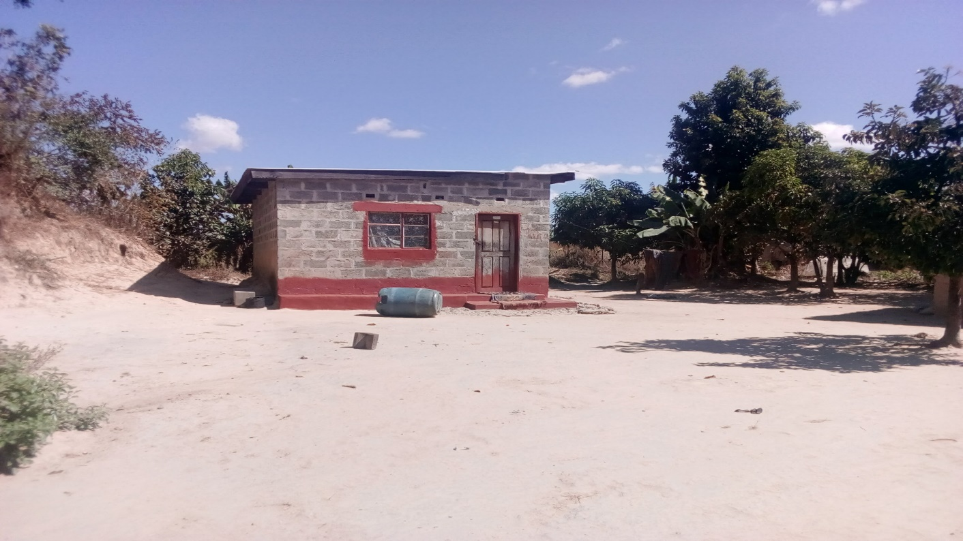
Margret Chitushi’s house
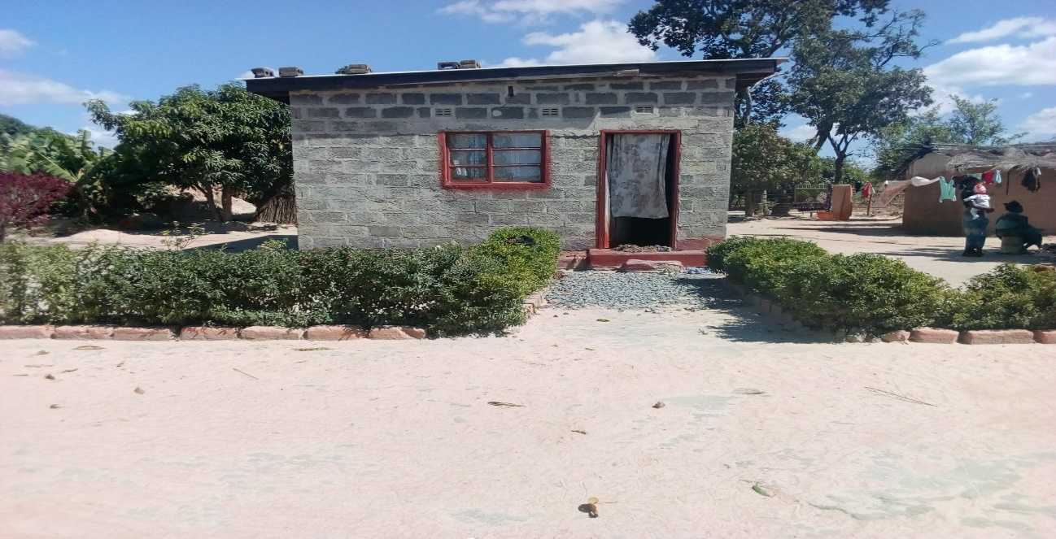
Beatrice Kashita’s house

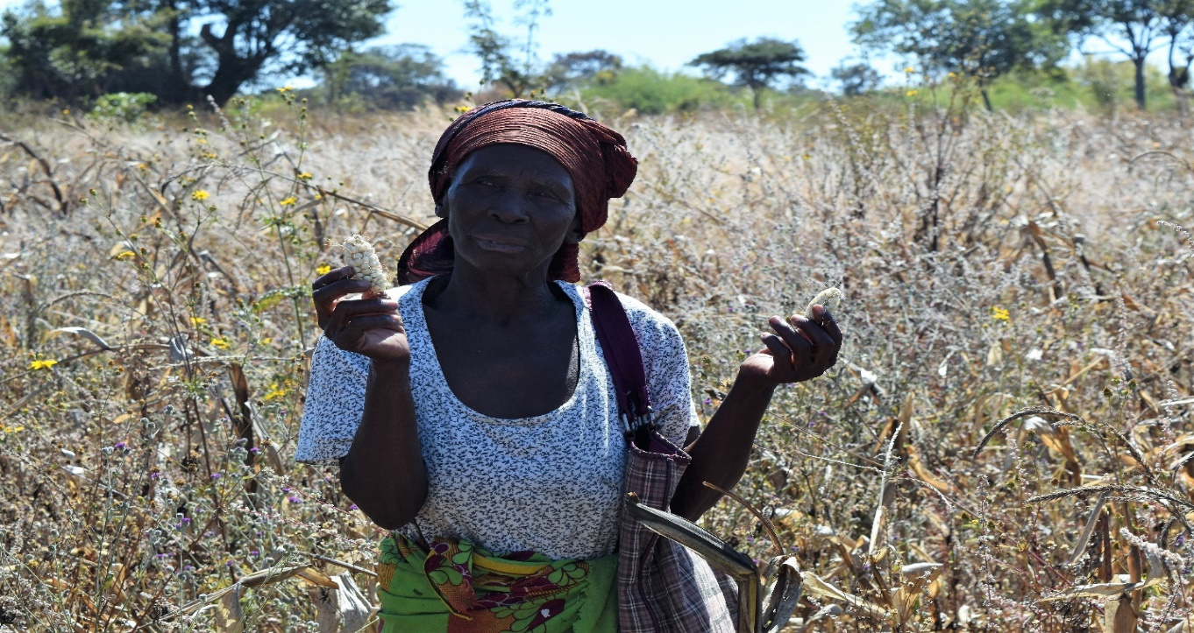
Margret Chitushi in her field showing the maize
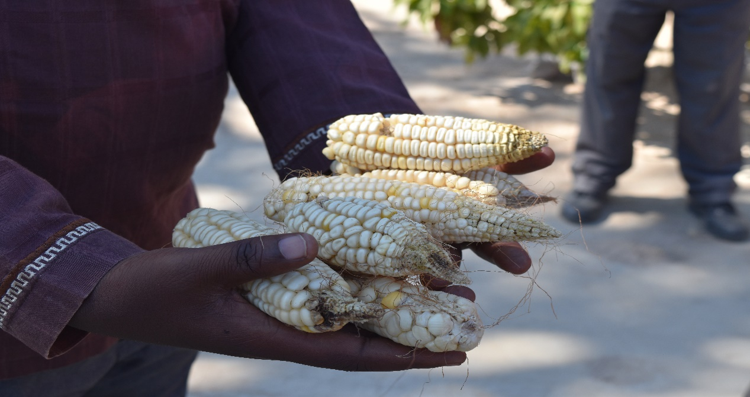
Some of the yield from the farming land at the resettlement

The community has requested that we call your attention to the above grievances for your intervention.
Your kind attention to this matter will be highly appreciated. We stand ready to work with you to address the local community’s plight.
Respectfully Submitted,
Mutinta Hadunka,
Governance and Community Liaison Officer,
Network for Community Resource Governance.

