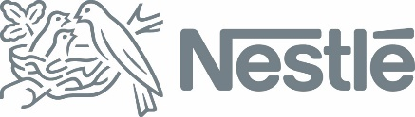

“Coffee and the blood of indigenous peoples”, https://www.rappler.com/thought-leaders/214549-coffee-blood-of-indigenous-peoples

Nestlé response, as of March 15, 2019:

According to our records, DM Consunji Inc. (DMCI), Silvicultural Industries, Inc. and M&S company do not supply coffee beans to Nestlé Philippines.

We have reviewed our coffee bean supplier records for the past 11 years, and none of these companies is in our list of suppliers nor do we have any contract with them.

We require all our suppliers to respect and adhere to our Responsible Sourcing Standard, which defines the non-negotiable standards when they do business with Nestlé, including adherence to all applicable laws and regulations and compliance with international and industry standards and best practices, including as they relate to indigenous peoples. Compliance with the Standard is regularly assessed and audited.

