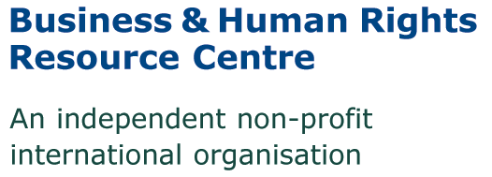
CONFIDENTIAL
Application form: Africa & Natural Resources Research & Projects Internship – NYC or Washington DC

Please type or write in black ink – Please answer all questions, and do not attach a CV.
Please return the completed form to us by email by 17 September 2018, to Christen Dobson at dobson@business-humanrights.org

* Note to those returning the application by e-mail: The end of the form asks for “Signature of applicant” -- you may simply type your name there. The successful applicant will be asked to sign the form before starting.

Personal details
Surname:
Forename(s):
Address:
Telephone:
Email address:

Position details
If appointed, when would you be able to start?

How many hours per week are you able to commit? (Note: We are seeking someone that can commit at 10-12 hours per week)

How many months are you able to commit to the internship? (Note: We are seeking someone that can commit to at least 3.5 months part-time)

Do you plan to seek academic credit for this internship? (Note: We are happy to support with information required from us in order to seek academic credit)

General information
Nationality:
Do you already have the right to work in the USA? (Please specify) Please note that due to lack of resources we are only able to take applicants with a valid work/internship permit, and are unable to offer sponsorship.
Where did you first learn about this intern position?

Languages
Please indicate level (Fluent, very good, good, intermediate, basic). Start with first language (“mother tongue”)
Language | read | write | understand | speak

Work experience
Please give details of relevant work experience, incl. voluntary work/internships. Start with most recent and do not exceed one page (add lines if necessary).
Dates | Details (name of employer, job title & brief description of your responsibilities) | Reason for leaving

Education and training
Please give details of your education and training, including courses you have attended and (if applicable) qualifications gained (add lines if necessary)
Date started | Date finished | Name of institution | Major/Areas of Concentration | Degree (if any)

Personal statement
Use this section to explain why you believe you are a good candidate for this internship, in particular how you meet our requirements and the experience you have that is relevant. Please use specific examples. (500 words maximum)

I confirm that the details in this form and any other information relating to my application are correct.

Signature of applicant: Date:

