August, 26th, 2019
1. ALBEMARLE REAFFIRMS ITS COMMITMENT TO SUSTAINABILITY IN THE SALAR DE ATACAMA
In consideration of the information submitted to Albemarle by the Centro de Information on Companies and Human Rights, we feel obliged to report that the data, values, background and comments exhibited by the review "Minería de lithium en el Salar de Atacama, Chile", EJOLT Atlas, 2017, lack, to a large extent content, rigour and, in some cases, veracity. We regret that an institution of this nature disseminates and endorses this publication, in which reputation-damaging claims are made of a company that has been characterized as being a pioneer in the development of a new paradigm in the relationship with communities and with a commitment to sustainable management.
Below we share accurate and verifiable information regarding our operations in Chile to illustrate the numerous inaccuracies of the published report.

1.1 GENERAL BACKGROUND REGARDING ALBEMARLE
Albemarle is the largest lithium producer in the world, and the company has had a presence in Chile for almost 40 years. A strategic partner of the Chilean State, the company’s governance is characterized by the highest international standards in ethical, community and environmental matters.
We have more than five thousand workers in the world. In Chile, we directly employ more than 700 people, and more than 4,000 indirect jobs exist as a result of our operations. More than 80% of our employees live in the region of Antofagasta, where our two plants, the Salar Plant and La Negra Planta are located. Nearly 40% of our employees in the Salar de Atacama are from the indigenous communities bordering the salt flats.

Albemarle is dedicated in Chile to the extraction and processing of brines and to the production of carbonate and lithium chloride. We are an innovative company, committed to the environment and part of one of the world's most important lithium producers. Albemarle Corporation is headquartered in Charlotte, North Carolina.
We were the developers of the lithium industry in Chile along with the Corporación de Fomento, CORFO, with whom we signed a historic agreement in 2016 providing us with the authorization to operate in Chile until the year 2043. This agreement includes a series of conditions that generate important contributions to the State of Chile: the payment of commissions on sales, which can reach up to 40%; US $300 million in contributions for Research and Development; and the requirement to offer of up to 25% of our lithium production at a preferential price to companies that invest in Chile to produce value added products. There are no similar conditions that are applied to any other company in Chile.
We also have a relationship of trust and respect with the communities of the Salar de Atacama basin, which has been built since we began our operations there in the early 1980s. An example of this are the historic and unique Cooperation, Sustainability and Mutual Benefit agreements that we signed in 2012 with the Atacameña Community of Peine and 2016 with the Council of Atacameños People (CPA) and with each of the 18 indigenous communities of the Salar of Atacama. More than 70% of these agreements are related to the promotion of the sustainability of the Salar de Atacama. We have permanent monthly meetings with all the communities of the Salar. An example of this is that with the community of Peine we have already held more than 75 formal meetings and 33 meetings with the CPA since the signing of the agreement, which shows that these agreements have substance and truly provide for a routine and transparent dialogue between the two parties. In addition, we share 3.5% of our sales for community development projects, mainly in education, innovation and entrepreneurship. This voluntary agreement between the parties, which was requested by the Council of Atacameños Peoples itself and the 18 Communities that compose it, does not include any clause that establishes that communities are inhibited from taking action against us (See Section 1.3 of this document). This agreement is unique in Latin America, and one of the few in the world.
The article published in this platform refers to the filing of the project "Modifications and Improvement of the Solar Evaporation Well System in the Salar de Atacama", which was presented in 2009 and which the company subsequently improved.
Proof of this evolution and improvements is that the Project "Modifications and Improvement of the Solar Evaporation Well System in the Salar de Atacama", was unanimously approved by the Environmental Assessment Commission of the Antofagasta (CEA) on Monday 18 January 2016. As established through the approval of this project, it is a project that has no environmental impact and it includes a number of direct benefits to the community. The Project consisted of a request to increase the authorized quota for the extraction of brine (mining resource) that the company from 142 l/s to 442 l/s.
It should be noted that the lithium production process carried out by Albemarle in the Salar of Atacama does not require fresh water.
At present there are 5,107.7 L/s of water rights granted in the basin to different users. The mining sector has rights for 2,839 L/s, of which only 23.5 L/s correspond to Albemarle, which is equivalent to 0.8% of the total. Of these23.5 L/s, only half is used.
Lithium is produced from brine, a mining resource, which, after a process of 18 months, using exclusively the energy of the sun, achieves the concentration necessary to be transferred to the Chemical Plant La Negra, in Antofagasta, where the brine goes through a complex chemical process.
This new environmental permit (2016) was granted after Albemarle developed a new hydrogeological model of the Salar de Atacama in order to guarantee the sustainability and equilibrium of that ecosystem. This study lasted six years, and the company invested more than $20 million US dollars to develop the most sophisticated model to date of the Salar.
With the presentation of this hydrogeological model, which is the tool for that exists and serves as a basis for authorities, communities, and other companies with operations in the area, Albemarle established a new standard for the sustainable extraction of the Salar de Atacama.
Environmental commitments were also established:
- 150 monitoring points in the Salar Basin
- Early Warning Plan
- Permanent Water Monitoring Plan
- Biotic Monitoring Plan: Flora, Vegetation, Fauna, Soil, among others
- Periodic measurement of the level of the lagoons
Also, and on a voluntary basis, with specific projects and deadlines, we carry out:
- Flamingo Monitoring Plan
- Study of microorganisms of the extremities
- Study of the zonal and surrounding vegetation
In order to meet these commitments, we work in conjunction with the local communities, through participatory, voluntary and integrated monitoring.

1.2. ENVIRONMENTAL ASPECTS OF THE SALAR DE ATACAMA BASIN
In relation to the environmental aspects mentioned in the aforementioned article, we would like to make the following clarifications.
The Salar de Atacama basin is an endorreic basin, that is to say, it is a closed basin, with no surface runoff out of it. In this way, in a regime of natural (without human intervention) the water that falls as precipitation can be to store like snow in the high parts, to drain superficially (mainly sporadically during the rains) or to be infiltrated and to flow underground to the Salar. In addition, during the natural transport of the water towards the Salar, there are natural losses of water resources associated with the processes of evapotranspiration.
The basin, as shown in Figure 1 can be divided into 3 main sectors: Recharge Zone, Marginal Zone and Nucleus.
The Recharge Zone is so called because it is the zone in which the precipitation occurs infiltrating underground aquifers and generates recharge in existing aquifers. The Nucleus plus the Marginal Zone make up the Salar and correspond to the lowest zone of the basin (2,300 m a.s.l.).
In the Recharge Zone and in the Marginal Zone there are fresh and brackish water, respectively. It is in these areas where the population and the sensitive ecosystems that make use of water resources (fresh water and brackish water respectively) are located.
In the Nucleus there is no fresh or brackish water, only brine is present. This brine has been formed over centuries by the natural process of evaporation and corresponds to a liquid mixture with a very high salt content. It is not suitable for human consumption, cannot be used for watering and there are no animals that the use for sustenance.
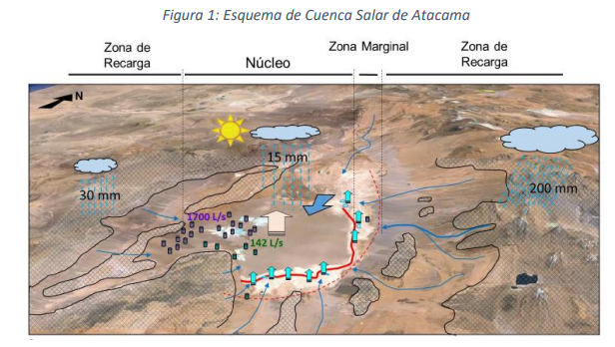
According to publicly available information, the average water inlet (in form of precipitation) to the basin of the Salar de Atacama varies between 5,200 and 5,600 L/s.
Currently (Figure 2) there are 5,107.7 L/s of water rights granted in the basin^{1.} . The mining sector has rights for 2,839 L/s, of which only 23.5 L/s are by Albemarle² (0.8% of the total).
It is important to highlight that the water of the Salar de Atacama basin is what from the high areas towards the Salar in natural conditions and then forms of centuries the brine, which is the resource used by Albemarle. Albemarle is the first interested in the brine continuing to be generated without diminishing the resource available for sensitive ecosystems and community consumption. Albemarle for extracting brine from waters beneath sensitive ecosystems and the consumption of human groups does not affect the availability of this resource.
With regard to brine, there are currently two companies authorized to extracting brine from the Nucleus: SQM (1,500 L/s up to 2020, reaching 1,700 L/s until 2030) and Albemarle (442 L/s). Currently, Albemarle extracts the 22.7% of total extraction.

¹ The largest extractions of water correspond to those of the mining companies Escondida and Zaldívar, with an approximate consumption of 1,600 L/s from the southern sub-basin of the Salar de Atacama (recharge zone). By on the other hand, SQM is environmentally authorized to pump 240 L/s of water from the eastern recharging zone of the Salar.
²Albemarle has authorised 1,200 L/day of water for the consumption of its workers (0.0139 L/s, not 1,200 L/s as mentioned in the text). This water is purchased from third parties. (See page 20 of Annex 4 of the Addendum 5 to the project "Modification and improvement of the solar evaporation wells in the Salar de Atacama", http://seia.sea.gob.cl/archivos/2015/12/12/Anexo_4_-_Fichas_Ambientales_Actualizadas.rar)

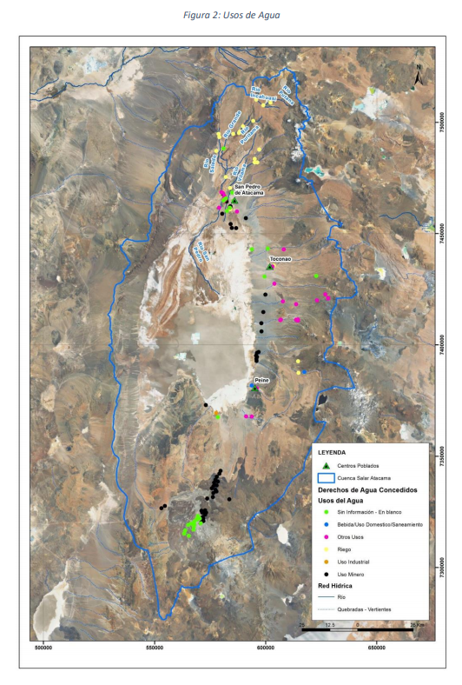

1.3. A NEW PARADIGM IN THE RELATIONSHIP COMMUNITY: ALBEMARLE AND INDIGENOUS COMMUNITIES OF THE SALAR OF ATACAMA.

In February 2016, after a long period of talks, dialogue, work spaces and collective construction, the Council of Atacameños Peoples, the 18 indigenous communities of the Lickanantay ethnic group and Albemarle signed a unprecedented agreement in the field of community relationship in national mining and worldwide. This agreement, which recognizes what is established in the national indigenous law and includes and incorporates the highest standards proposed in the Declaration of the United Nations United Nations on Indigenous Peoples' Rights and standards established by the OIT through Convention 169 on Indigenous and Tribal Peoples in Independent Countries, has as objectives:
a) To protect, promote and develop the Atacameña culture;
b) To promote the spiritual, social and material well-being of the members of the and their communities;
c) To conserve the habitat of the Salar de Atacama and, in general, of the territorial space shared by the Communities and the Company in the ADI Atacama La Grande;
d) Protecting the waters and lands of the representative institutions of the Atacameños peoples must watch over the parts for their sustainable use, of not to damage the ecosystem and their habitat;
e) Project the Company's operations and activities into the future, such as a relevant actor in the sustainable development of the Communities, of the localities in which they live and their inhabitants.

The agreement is considered historic, both in the country and worldwide, because a new form of understanding with the indigenous communities and that is going to be beyond the delivery of money and involves putting into practice the fundamentals of the of New Lithium Mining, in which the company engages in dialogue, sustainability and added value.
Its signature is the result of a process of approachment, dialogue and collaboration between the parties that began in 2012, when the Council of Atacameños Peoples and the 18 communities that compose it verify the good will of the Company to establish fruitful dialogues, when the Cooperation and Sustainability Agreement is revised, that had been signed that same year between Albemarle and the Community of Peine. For this reason, the People's Council convenes the Company to establish a dialogue process in order to reach an agreement volunteer. As a result of this process in 2014, an agreement was signed for understanding, which established how to dialogue in order to reach an agreement of collaboration with a standard that would meet the requirements established by the OIT (Convention 169) and the UN (its principles). The foregoing shows that it is the voluntary dialogue processes, with respect to the times and processes of the parties, those who manage to culminate successfully. An example of this is that the decisions that were evaluated between the parties, each of the communities had to approve them in their assemblies, and then present them again before the Council and the Company.
This is one of the reasons why the process took 4 years to reach a final agreement, which makes it absolutely successful (lacks impositions, and is characterized by the respect and voluntary nature of the process).
One of the main aspects of the agreement is that the company undertakes to share the benefits of lithium extraction and production of lithium and their derivatives generates by the company: annually the company delivers to the communities the equivalent to 3.5% of sales of Lithium Carbonate and Potassium Chloride produced with brine from the Salar Plant.

The foregoing is based on OIT Convention 169 in its article 15 N°1 and N°2 which states that "indigenous peoples shall participate, wherever possible, of the profits derived from the activities of prospecting for or exploiting the resources of the minerals or subsoil resources". On the other hand, the National Lithium Commission, in its Final Report entitled "Lithium: An energy source an opportunity for Chile", proposes that the materialization of these articles be through the participation of communities of a proportion of sales and royalty that the Chilean treasury collects annually, in a proportion of not less than three per cent.

The annual contribution referred to in the Agreement corresponds to the agreed mechanism between the communities, the Council and Albemarle, in order to concretize the participation of the communities in the benefits the company derives from the extraction of brines and their derivatives in the Salar Plant.

It is now three years since the agreement was signed in which 18 Atacameñas Indigenous Communities of the Salar de Atacama are participating, which established a new paradigm in relationships between Indigenous Communities and national mining industry. Thirty-three permanent working groups have been set up with all the community leaders and Company representatives.

An essential part of these Conventions (as noted above) and of the requirements of the Resolution of Environmental Qualification (RCA) Nº 0021 of the 20 of January of 2016 authorizing the project "Modifications and Improvement of the System of Solar Evaporation Wells in the Salar de Atacama", is the promotion of the sustainability of the Salar, for which the implementation of a program of participatory environmental monitoring with the indigenous communities of the Salar de Atacama was developed.

In order to formalize this monitoring program, a Protocol was established with the 18 Atacameñas communities of Salar de Atacama, signed in April 2017, that is intended to implement the participatory environmental monitoring program in the Salar de Atacama and its basin, in order to determine its current condition and ensure its long-term sustainability.

The Protocol is implemented through the constitution of a Monitoring Environmental Committee made up of 36 people representing the communities and 5 from Albemarle. This committee meets monthly, and it is trained around the topics of environmental variables that the company must monitor, by virtue of what has been established by the Environmental Authority. In addition to this Committee, a Technical Secretariat is constituted, made up of professionals in the environmental area who are in charge of support the participatory environmental auditing carried out by the communities to Albemarle. In addition, the Company requests authorization from the communities prior to the conduct of any monitoring activity, and the communities send observers to collaborate with the monitoring. After each one of the monitorings, Albemarle sends the results reports.
The parties conduct environmental trainings (8 in 2018) to all the parties representatives of the Committee, on topics associated with the environmental components which must be monitored as required by the authority. The specific theme, the agenda, dates, locations and speakers of the workshops are defined by the Environmental Committee, which demonstrates the nature of the training inclusive and participatory model implemented.

On the other hand, the Company will finance the constitution of the new stations of monitoring (in addition to those already required by the environmental authority) so that they are administered by the Communities, by mutual agreement. It is important to emphasize, that it will be the Environmental Committee in conjunction with the company who will define the specific points where the stations will be installed.

In addition to the foregoing, the Company formally transfers to the Communities twice a year, all environmental information reported to the Authority.

It is important to point out that in addition to the meetings and activities mentioned above, the Environmental Committee (as noted above, consisting of representatives of the following all communities - 36 people - more Albemarle representatives – 5 people), reports month by month on all the activities carried out to the leaders of the Atacameñas communities in the framework of the Permanent Working Tables (MTP) that have been carried out every month since 2016.

The development of this collaborative work has allowed:
- To strengthen the relationship between Albemarle and the Atacameñas Communities of the Salar de Atacama.
- Collaboratively promote the sustainability of the Salar.
- Obtain the Social License for the improvement and expansion of the ponds system.

It has also made it possible to promote the following opportunities for improvement:
- Promote a common vision of the territory.
- Incorporate the sustainability as a central aspect in the vision of the company in Chile.
- Contribute to environmental monitoring and follow-up (Environmental Monitoring Committee participative).
- Establishment of a channel of communication and permanent dialogue (Permanent Working Tables and monthly meetings with the Monitoring Committee Environmental).
- Opportunity to generate added value and shared value.

All of the above demonstrates a single objective: to promote processes of dialogue and cooperation based on the good faith of both parties and with a view to sustainable development of both lithium mining and itself communities.

Through this agreement, Albemarle and the communities become members, not only because they share the benefits of the activity, but rather because they enhance their own development, working together to ensure a sustainable operation of the Salar de Atacama.

Finally, we reiterate our greater commitment to the development of the new Lithium Mining, which is built on dialogue, sustainability and the ability to generation of shared value.

