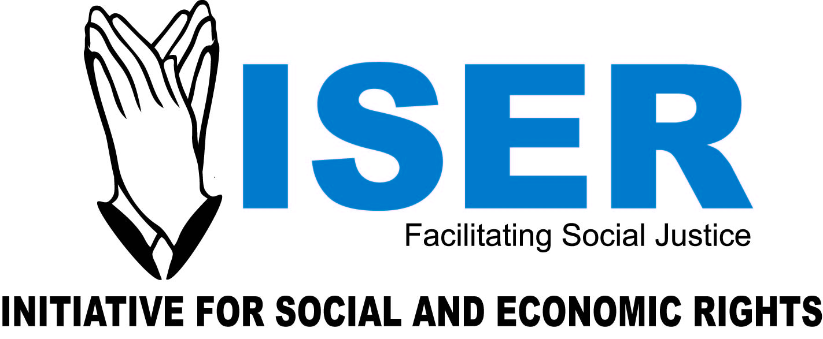
Logo
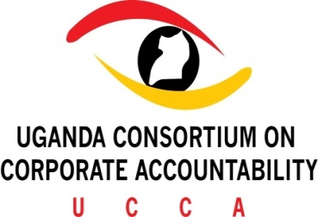

THE 3RD ANNUAL NATIONAL CONFERENCE ON ECONOMIC SOCIAL AND CULTURAL RIGHTS

Call for Abstract Submissions

The Annual Conference on Economic, Social and Cultural Rights was inaugurated in 2014 by a group of organisations comprising of the Initiative for Social and Economic Rights (ISER), the Center for Health, Human Rights and Development (CEHURD), the Human Rights Network-Uganda (HURINET) and the Public Interest Law Clinic (PILAC) of the School of Law, Makerere University. Lately, Global Rights Alert and the Uganda Human Rights Commission (UHRC) have joined the team.

The 3rd Annual National Conference is scheduled for 14th and 15th September 2016 at Makerere University Main Hall. The Conference will this year be held under the theme; “Business and Human Rights in Uganda: Accountability V. Social Responsibility for Corporate Abuses.” The conference organizers invite all interested persons and organizations to make submissions of abstracts for proposed individual presentations or panel discussions during the conference.

The submissions may address, but are not limited to, the following thematic areas:

- Development of National Action Plans on Business and Human Rights.
- Sustainable development goals and Business and Human Rights.
- Protect, Respect and Remedy in practice: Progress and challenges in implementing corporate responsibility and accountability.
- Implementation of UN Guiding Principles on Business and Human Rights in decision-making processes.
- The role of international, regional and national CSOs in promoting Business and Human Rights principles.
- State Obligation to protect against human rights violations by non-state actors.
- Ensuring free, prior and informed consent in developmental projects as a driver for sustainable development.
- Health Rights and workplace safety.
- National legal framework on Business and Human Rights.
- Case-studies on Business and Human Rights, among others indicating best practices or lessons learnt.
- Judicial decisions with implications on Business and Human Rights.
- Extra-Territorial Obligation of States for Corporate Abuses.

The deadline for submission of abstracts is the 5th of August 2016. Abstracts should not be more than 500 words in length.
The Organsing Committee is not in position to meet the costs of travel, subsistence and accommodation associated with attending/presenting at the Conference.
Please see attached the Conference Concept Note for further guidance. Any other inquiries regarding this call and the Conference should be directed to the organizers at ucca@iser-uganda.org or kwagala@cehurd.org.

