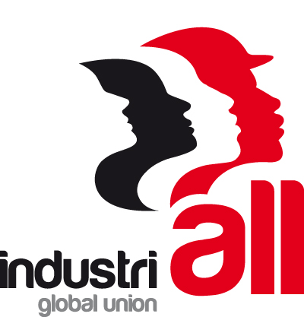

20 November, 2014

Statement from IndustriALL Assistant General Secretary Kemal Özkan:

IndustriALL is extremely disappointed by Rio Tinto’s continued refusal to speak publicly about what it will do to end the string of deaths at the Grasberg mine in Indonesia.

IndustriALL called on Rio Tinto to seriously address this matter following two fatal incidents in which five Grasberg miners died in September. Rio Tinto responded with a one paragraph, unsigned statement in which it again distances itself from responsibility for the killings and notes it is offering Freeport advice. This is a wholly inadequate response given the size of Rio Tinto’s investment in Grasberg and the gravity of the problem, and it gives the thousands of Grasberg mineworkers little confidence that they will remain safe.

Rio Tinto’s hypocrisy in how it talks about Grasberg is stunning. In its annual report, Rio Tinto says Grasberg is part of its “core portfolio of Tier 1 assets”. However, following fatal incidents, Rio Tinto has remained silent or, when pressed, has denied responsibility by referring to “the Grasberg mine operated by Freeport.”

Rio Tinto claims to be a sustainable company, but a sustainable company would not reap the benefits from a mine while denying responsibility for its impact. Rio Tinto’s share of mined copper production at Grasberg was six thousand tonnes in 2013, but the company acts like it has no responsibility to keep the workers safe.

IndustriALL will continue to work with our affiliated union at Grasberg to push for health and safety improvements, and we would welcome Rio Tinto’s support in that process. It’s high time for Rio Tinto to take the health, safety and lives of the Grasberg miners seriously.

